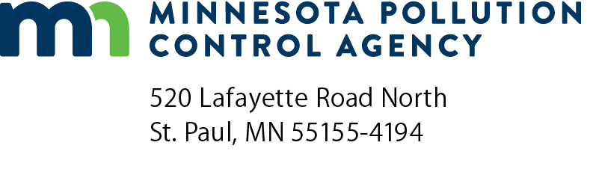 | Get the Lead Out (GTLO)  Lead-Free Fishing Tackle Rebate Program  Application FY 2022  Doc Type: Grant Application
Instructions: Please read the complete Get the Lead Out (GTLO) – Lead-Free Fishing Tackle Rebate Program Request for Proposal (RFP) before submitting this application.
Submit application to: grants.pca@state.mn.us with the subject line: Get the Lead Out Rebate Rolling Application.
Applications will be accepted until all dedicated funds have been dispersed or 4:00 pm Central Time on Friday, March 29, 2024, whichever occurs first. To be eligible for a rebate, purchases must be completed within one year of grant execution, or by Friday, June 28, 2024, whichever occurs first.
Eligibility: In order to be eligible for the GTLO Lead-Free Fishing Tackle Rebate program, an applicant must meet all of the following criteria:
- Eligible applicants include owners or operators of brick-and-mortar retail establishments physically located in Minnesota that sell fishing bait and tackle; and
- Eligible applicants must be for-profit business with 100 full-time equivalent employees or less (including parent companies and all business operations).
Applicant Information
Retail establishment name:
Retail establishment street address:
City: |  |  |  |  | State: |  |  |  | Zip code: |  |  | County:
Contact name:
Phone: |  |  |  |  | Email address:
Retail establishment website (if you have one):
Eligibility Information
Is the above retail establishment a brick-and-mortar store physically located in Minnesota? Yes No
Does the above retail establishment sell fishing bait and tackle? Yes No
Is the above retail establishment a for-profit business? Yes No
Number of full-time equivalent employees (including parent companies and all business operations):
Anticipated grant funds requested: $

