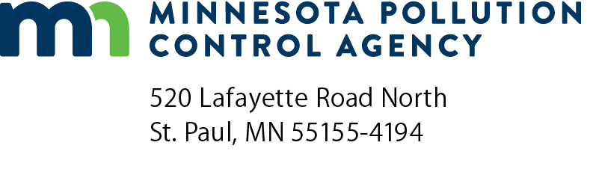 | Get the Lead Out (GTLO)  Lead-Free Fishing Tackle Rebate Program  Application FY 2025-2027  Doc Type: Grant Application
Instructions: Please read the complete Get the Lead Out (GTLO) – Lead-Free Fishing Tackle Rebate Program Request for Proposal (RFP) before submitting this application.
Submit application to: grants.pca@state.mn.us with the subject line: “Get the Lead Out Rebate Rolling Application.”
Applications will be accepted until all dedicated funds have been dispersed or 4:00 pm Central Time on Wednesday, March 31, 2027, whichever occurs first. To be eligible for a rebate, purchases must be completed within one year of grant execution, or by Wednesday, June 30, 2027, whichever occurs first.
Eligibility: In order to be eligible for this rebate program, an applicant must meet all of the following criteria:
- Owners or operators of brick-and-mortar retail establishments physically located in Minnesota that sell fishing bait and tackle (franchise owners or operators included); and
- Must be for-profit business with 100 full-time equivalent employees or less (including parent companies and all business operations).
Applicant Information
Retail establishment name:
Retail establishment street address:
City: |  |  |  |  | State: |  |  | Zip code: |  |  | County:
Contact name:
Phone: |  |  |  |  |  |  |  | Email address:
Eligibility Information
Is the above retail establishment a brick-and-mortar store physically located in Minnesota? Yes No
Does the above retail establishment sell fishing bait and tackle? Yes No
Is the above retail establishment a for-profit business? Yes No
Number of full-time equivalent employees (including parent companies and all business operations):
Anticipated grant funds requested (up to $3,000, see example calculations* below for reference): $
Note: Requested amount cannot be changed once enrolled.
Applicants have the entirety of their enrollment period (one-year from grant agreement start date or by Wednesday, June 30, 2027, whichever occurs first) to send in rebate submissions to draw down their requested grant funds balance. Applicants are not required to utilize all requested funds.
While enrolled, applicants may make multiple purchases, and in turn, send multiple rebate submissions to draw down their balance. Meaning, applicants do not have to use up the entirety of their requested grant award with one purchase/invoice.
*Example Calculations:
Applicants should request 45% of the dollar amount that they anticipate spending on eligible, lead-free tackle while enrolled. For example, applicants should request:
$450 in grant funds, if they anticipate spending up to $1,000 on eligible, lead-free tackle while enrolled.
$1,125 in grant funds, if they anticipate spending up to $2,500 on eligible, lead-free tackle while enrolled.
$1,800 in grant funds, if they anticipate spending up to $4,000 on eligible, lead-free tackle while enrolled.
$2,475 in grant funds, if they anticipate spending up to $5,500 on eligible, lead-free tackle while enrolled.
$3,000 in grant funds (max), if they anticipate spending up to or more than $6,666.67 on eligible, lead-free tackle while enrolled.

