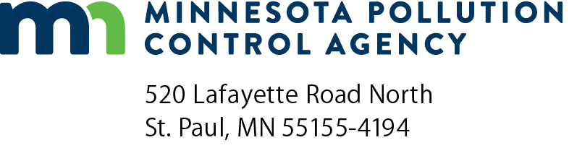 | PFAS Source Identification and Reduction Grant Program  Grant Application  Doc Type: Grant Application

Instructions: Please read the complete Request for Proposal (RFP) and other associated documents before submitting this application. Any expenses incurred before the contract is fully executed are ineligible. The award maximum is per applicant/organization.
Email application to: grants.pca@state.mn.us with the subject line, “PFAS Source Identification and Reduction Application.” Applications will be accepted until all dedicated funds have been dispersed or 4:00 p.m. Central Time on Wednesday, April 2, 2025, whichever occurs first.
- Project information
Organization name:
Organization address:
City: |  |  |  |  |  | State: |  | Zip code: |  |  |  | County:
Contact name: |  |  |  |  |  |  |  | Title:
Phone: |  |  |  |  |  | Email address:

Project address, if different from above:
City: |  |  | State: |  | Zip code: |  | County:

Grant requested: | $ | + Matching funds: | $ | = Total project cost: | $
Is the applicant also applying for Small Business Loan funding for this project? Yes No
Note: Use of Small Business Loan funding does not increase or decrease the likelihood of receiving a grant and applicants will not be evaluated on their use of these funds.
- Project details
Project title:
Provide a detailed description of the project. Describe the identified need for this project and severity of the problem.
Include project goal(s), timeline(s), and final deliverable(s). Add additional pages, as needed.

Budget
Provide a detailed, itemized budget that includes reasonable and cost-effective expenses. Add additional pages, as needed.

Eligibility Questions | Yes | No
Is the project located in or will it benefit an underserved community or an area that has been identified as a location of environmental justice concern*?
*Using the MPCA’s criteria and interactive mapping tool (recently updated on the MPCA website), identify if the proposed project, or the direct benefit from the project, is located in one or more of MPCA’s identified environmental justice (EJ) areas of concern.
Submit a map and/or description. Use additional sheets if necessary.
Are you one of the following?
- Municipality
- Private and public solid waste management facilities
- Industrial facilities contributing PFAS to a municipal wastewater treatment system or the environment
- Industrial Stormwater facility contributing PFAS to a municipal wastewater treatment system or the environment
Have you voluntarily participated in or were you sampled by an MPCA contractor as part of the MPCA PFAS Monitoring Plan**?
If yes, which of the following do you meet?
- Municipal Wastewater PFAS Monitoring MOU participants
- Industrial facilities that participated in or were sampled as part of an MPCA PFAS Monitoring Plan
- Solid waste management facilities that submitted a Sampling and Analysis Plan or signed an MOU with the MPCA for the PFAS Monitoring Plan by April 1, 2023.
** Reference the list of Facilities included in the PFAS monitoring plan.
Does your project meet one of the following?
Preparation and execution of PFAS Pollutant Management Plans.
Source identification work, including waste stream sampling, to identify sources of PFAS entering wastewater treatment systems or solids waste management facilities.
Identification of PFAS containing products and the implementation/use of products which are PFAS-free.
Identification of process equipment that may need to be replaced in the future due to historic PFAS use and/or PFAS contamination.
Industrial Stormwater related projects that include source identification and reduction of PFAS at auto shredders, metal finishers and/or airports.

