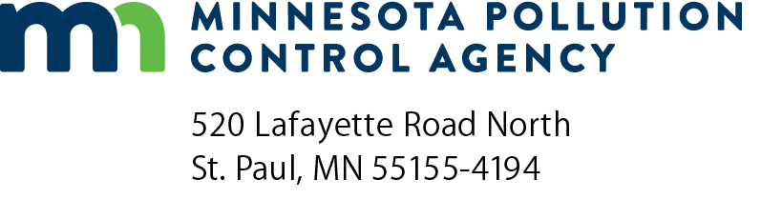 | Credit card authorization form  Wastewater Operator Certification Program
Instructions: You may complete this form electronically; then print and mail or fax it with your payment.
Do not email this form as an attachment with credit card information.
Send to: | Training registration: | Examination and certification applications:
 | Christi Torgusson – 5th floor  Minnesota Pollution Control Agency  520 Lafayette Road North  St. Paul, Minnesota 55155-4194  651-757-2482 | Tracy Finch – 5th floor  Minnesota Pollution Control Agency  520 Lafayette Road North  St. Paul, Minnesota 55155-4194  651-757-2103
Secure fax: | 651-797-1385

Credit card information
Visa MasterCard |  |  |  |  |  | Exact name on card:
Card number: |  |  |  |  |  |  |  |  |  | 3-digit security code: |  |  |  |  | Expiration date:
Address:
City: |  |  |  |  |  |  |  |  |  |  | State: |  |  |  |  | Zip code:
Phone number: |  |  |  |  |  |  |  |  | Email address for receipt:
Name of person taking class/exam: |  |  |  |  |  |  |  |  |  |  |  |  |  | Date (mm/dd/yyyy):
Signature: |  |  |  |  |  |  |  |  |  |  |  |  |  |  |  |  | Amount:

Service fees
US Bank will be charging a separate service fee of 2.15% for all credit card transactions and 1.25% for all debit card transactions after April 1, 2022. To avoid these service fees, you may submit your payment by mail to the Minnesota Pollution Control Agency (MPCA) at the address provided on this form.
Check here to agree to pay the separate service fee of 2.15% to US Bank for credit card payment and 1.25% for debit card payment. Credit card payments after April 1, 2022 will not be processed if box is not checked.

