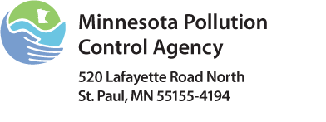 | Industrial Facility Mercury Sector Worksheet  National Pollutant Discharge Elimination System (NPDES) Wastewater Program  Mercury Minimization Plan  Doc Type: Pollutant Minimization Plans

List of all possible industrial facility contributors | Business name  Contact name  Date contacted | Does the facility use large amounts of caustic soda or acid? | Hg concentration from industry? | Flow of industry | Total Hg loading from industry
Industrial laundries |  | Yes No
Laboratories |  | Yes No
Veterinary Clinics |  | Yes No
Printing industry |  | Yes No
Pottery and arts |  | Yes No
Automobile services |  | Yes No
Scrap dealers |  | Yes No
Landfill leachate |  | Yes No
Wet scrubber water that is not pretreated |  | Yes No
Other (electroplaters, metal finishers) |  | Yes No

Resources:
U.S. Environmental Protection Agency (EPA) Mercury Web site http://www.epa.gov/mercury/
Interstate Mercury Education and Reduction Clearinghouse (IMERC) http://www.newmoa.org/prevention/mercury/imerc.cfm
Western Lake Superior Sanitary District (WLSSD) data showed that industry was contributing 250 times more mercury to the treatment plant than laboratories or individual dentists, even though the concentration of mercury in its wastewater was the lowest measured. When prioritizing pollution prevention activities, it is important to measure or estimate flow and not to rely strictly on concentration data. WLSSD Case study included in WLSSD “Blueprint for Mercury Elimination,” pages 10 and 11 at http://www.wlssd.com/documents/WLSSD_Blueprint_Mercury_Reduction.pdf.

