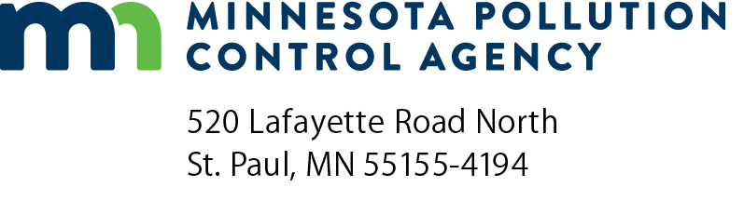 | Dissolved Air Flotation Thickening  Review Checklist  NPDES/SDS Permit Program  National Pollutant Discharge Elimination System (NPDES)/  State Disposal System (SDS)  Doc Type: Plan/Specification Review Summary
Purpose: This checklist is intended for use by design engineers, to assist Minnesota Pollution Control Agency (MPCA) review engineers in the efficient review of planning and design documents. The information requested is the minimum technical data necessary for MPCA staff to review proposed designs and to determine whether there is reasonable assurance that the treatment system, when constructed, will comply with permit conditions, regulations, and criteria of the MPCA.
Instructions: The information in this checklist is based on the Recommended Standards for Wastewater Facilities published by the Great Lakes Upper Mississippi River Board of State and Provincial Public Health and Environmental Managers (Ten State Standards) 2014 Edition, other accepted engineering references, and MPCA recommendations. Specific references, other than Ten State Standards, are listed where appropriate. The checklist is organized according to the numbering sequence found in Ten State Standards to allow for ease in locating the entire content and text of the recommendations.
The checklist is designed so that a “yes” answer indicates compliance with Ten State Standards et al.
A “no” answer indicates a deviation from Ten State Standards et al. Answering “no” to any question will require justification that can be provided at the end of the checklist and possibly supporting information, from wastewater treatment plant operational data, to demonstrate how the intent of the recommendation will be met. Additional information may be requested based on site specific conditions.
A “N/A” answer means not applicable because the equipment associated with the question is not included in the design.
Wastewater Treatment Facility information
Date (mm/dd/yyyy): |  |  | MPCA Project No:
Title of project:
Permittee information
Facility name:
Contact name and title: |  | NPDES/SDS Permit No: | MN
Email: |  | Phone number:
Design Engineer information
Contact name: |  | Contact phone number:
Email:
Phase: Planning Phase Design Phase
Influent Characteristics
Solids concentration |  | %
Sludge flow per day |  | gpd
83. Sludge Thickeners
(Only use a “NA” answer if the equipment associated with the question is not included in the design)
83.1 Design Considerations |  |  |  | Yes | No |  | N/A
Does the design of the thickener consider the type and concentration of sludge, the sludge stabilization processes, storage requirements, the method of ultimate sludge disposal, chemical needs, and the cost of operation?
Is particular attention given to the pumping and piping of the concentrated sludge and possible onset of anaerobic conditions?
Number of units:
Dimensions: |  | feet
Solids loading: |  | lb/hr/ft² | Recommended loadings below from M&E 2014
Type of sludge | Loading, lb/hr/ft²
 | Without chemical addition | With chemicals
Air activated sludge:
Mixed liquor | 0.25-0.6 | Up to 2
Settled | 0.5-0.8 | Up to 2
High purity oxygen activated sludge | 0.6-0.8 | Up to 2
Trickling filter humus sludge | 0.6-0.8 | Up to 2
Primary + air activated sludge | 0.6-0.8 | Up to 2
Primary + trickling filter humus sludge | 0.83-1.25 | Up to 2
Primary sludge only | 0.83-1.25 | Up to 2.5

Hydraulic overflow rate: |  | gpm/ft² | Recommended range of 0.5 to 2 gpm/ft² assuming use of no conditioning chemicals (MOP 8 1998)
Surface area: |  | ft²
Air/Solids ratio: |  | lb/lb | Recommended range of 0.005-0.060:1 (M&E 2014)
Sludge volume index: |  | mL/g | Recommended SVI < 200 using nominal polymer dosages (M&E 2014)
Solids recovery efficiency: |  | % | ≥ 98% with use of polymers as flotation aids (M&E 2014)
Pressure when dissolving air in water: |  | lb/in² gage | Recommended range of 30-70 lb/in² gage (U.S. EPA February 1980)
Recycle percent: |  | % | Recommended range of 15-120 percent (M&E 2014)
Detention period: |  | minutes
Operating cycle: |  | hrs/wk
Sludge blanket detention period: |  | hours
Are provisions made for polymer addition to increase solids recovery in the floated sludge and to reduce the recycle loads? (M&E 2014)
Is recycle flow metering controlled by influent flow? (M&E 2014)
Are provisions made for collecting sludge at the bottom of the tank? (M&E 2014)

83.2 Prototype Studies
Are process selection and unit process design parameters based on prototype studies if the sizing of other plant units is dependent on thickener performance?
Are the design criteria based on a testing program that can include bench-scale or pilot-plant testing? (M&E 2014)
Are the minimum solids loadings from the table above used if the design did not benefit from pilot studies? (M&E 2014)

Justification for all questions answered with a “no”:
Additional comments:
References
GLUMRB (2014 Edition) Recommended Standards for Wastewater Facilities (Ten State Standards), Health Research, Inc., Health Education Services Division, Albany NY.
Metcalf & Eddy, Inc. (2014) Wastewater Engineering, Treatment and Resource Recovery, 5th ed., McGraw-Hill, New York. (M&E 2014)
U.S. EPA (February 1980) Innovative and Alternative Technology Assessment Manual, U.S. EPA Office of Water Program Operations, U.S. Environmental Protection Agency, Washington, D.C. and Municipal Environmental Research Laboratory, Office of Research and Development, U.S Environmental Protection Agency, Cincinnati OH. (U.S. EPA February 1980)
WEF (1998) Design of Municipal Wastewater Treatment Plants, Manual of Practice No. 8, Water Environment Federation, Alexandria, VA. (MOP 8 1998)
Acronym definitions
ft² feet squared
gpd gallons per day
gpm gallons per minute
gpm/ft² gallons per minute per feet squared
hrs/wk hours per week
lb/hr/ft² pounds per hour per feet squared
lb/in² gage pounds per inch squared gage
lb/lb pound per pound
mL/g milliliters per gram
psi pounds per square inch
SVI Sludge Volume Index

