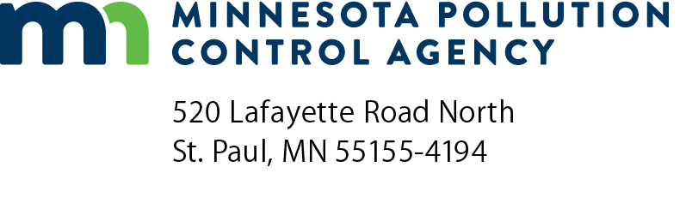 | Solid Bowl Centrifuge Review Checklist  NPDES/SDS Permit Program  National Pollutant Discharge Elimination System (NPDES)/  State Disposal System (SDS)  Doc Type: Plan/Specification Review Summary
Purpose: This checklist is intended for use by design engineers, to assist Minnesota Pollution Control Agency (MPCA) review engineers in the efficient review of planning and design documents. The information requested is the minimum technical data necessary for MPCA staff to review proposed designs and to determine whether there is reasonable assurance that the treatment system, when constructed, will comply with permit conditions, regulations, and criteria of the MPCA.
Instructions: The information in this checklist is based on the Recommended Standards for Wastewater Facilities published by the Great Lakes Upper Mississippi River Board of State and Provincial Public Health and Environmental Managers (Ten State Standards) 2014 Edition, other accepted engineering references, and MPCA recommendations. Specific references, other than Ten State Standards, are listed where appropriate. The checklist is organized according to the numbering sequence found in Ten State Standards to allow for ease in locating the entire content and text of the recommendations.
The checklist is designed so that a “yes” answer indicates compliance with Ten State Standards et al.
A “no” answer indicates a deviation from Ten State Standards et al. Answering “no” to any question will require justification that can be provided at the end of the checklist and possibly supporting information, from wastewater treatment plant operational data, to demonstrate how the intent of the recommendation will be met. Additional information may be requested based on site specific conditions.
A “N/A” answer means not applicable because the equipment associated with the question is not included in the design.
Wastewater Treatment Facility information
Date (mm/dd/yyyy): |  |  | MPCA Project No:
Title of project:
Permittee information
Facility name:
Contact name and title: |  |  |  | NPDES/SDS Permit No: | MN
Email: |  |  |  | Phone number:
Design Engineer information
Contact name: |  |  | Contact phone number:
Email:
Phase: Planning Phase Design Phase
Type of sludge: Primary Secondary Waste Activated Combination
Influent Characteristics
Solids concentration |  | %
Sludge feed rate |  | gpm
88. Sludge Dewatering
88.31 General |  |  |  | Yes | No
Are provisions made to maintain sufficient continuity of service so that sludge may be dewatered without accumulation beyond storage capacity?
Are there a sufficient number of vacuum filters, centrifuges, filter presses, belt filters, other mechanical dewatering facilities, or combinations thereof to dewater the sludge produced with the largest unit out of service?
Are adequate storage facilities of at least 4 days production volume provided, in addition to any other sludge storage needs, unless other standby wet sludge facilities are available?
Is documentation provided justifying the basis of design of mechanical dewatering facilities? Attach documentation.
Identify solids capture rate: |  | % | Typically >95% for polymer conditioned sludge (M&E 2014)
Identify cake solids concentration: |  | % | Typically 16-40% depending on type of sludge, assuming sludge is conditioned with a polymer (M&E 2014)

88.32 Water Supply Protection |  |  |  |  |  | Yes |  | No |  | N/A
Are provisions for water supply to mechanical dewatering facilities in accordance with Paragraph 56.23?
88.34 Ventilation
Are adequate facilities provided for ventilation of the dewatering area in accordance with Paragraph 42.75?
Is the exhaust air properly conditioned to avoid odor nuisance?
88.35 Chemical Handling Enclosures
Is chemical handling equipment automated to eliminate the manual lifting requirement? Refer to Section 57.
Identify chemical makeup and feeding equipment:
Identify conditioning chemical(s):
88.4 Drainage and Filtrate Disposal
Is centrate from dewatering units returned to the wastewater treatment process at appropriate points and rates?
Identify location for centrate return to plant:
Is sampling equipment provided as needed to monitor centrate and cake solids waste streams? See also Paragraphs 56.7 and 84.64.
Identify estimated centrate CBOD concentration: |  |  |  | mg/L
Identify estimated centrate flow rate: |  |  |  | gpd
88.5 Other Dewatering Facilities
Is a detailed description of the process and design data provided with the plans if other methods of sludge dewatering are proposed? Refer to Paragraph 53.2 for any new process determinations.

Justification for all questions answered with a “no”:
Additional comments:

References
GLUMRB (2014 Edition) Recommended Standards for Wastewater Facilities (Ten State Standards), Health Research, Inc., Health Education Services Division, Albany NY.
Metcalf & Eddy, Inc. (2014) Wastewater Engineering, Treatment and Resource Recovery, 5th ed., McGraw-Hill, New York. (M&E 2014)
Acronym definitions
gpd gallons per day
gpm gallons per minute
mg/L milligrams per liter

