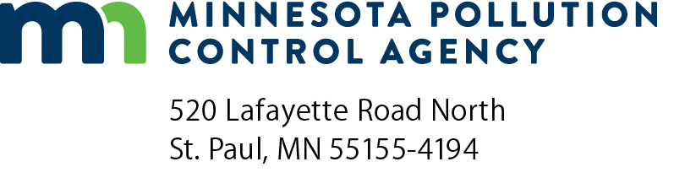 | CWRF B3 SB 2030 exemption form  Clean Water Revolving Fund (CWRF) Program  Wastewater Projects  (Minn. Stat. § 216B.241, sub. 1-10 and 16B, sub. 1-4)  Doc Type: Wastewater Point Source
Instructions: If at least one of the “Yes” statements is checked, the project is considered to have completed these requirements and is not required to submit additional information to meet the Building, Benchmarks, and Beyond (B3) provisions of the Sustainable Building (SB) 2030 Guidelines (B3 SB 2030). Sign and send the completed form electronically to the Minnesota Pollution Control Agency (MPCA) review engineer.
If the answer to all of the statements is “No”, sign and send the completed form electronically to the MPCA review engineer. Once the Facilities Plan receives preliminary approval [Minn. R. 7077.0272], submit it to B3 SB 2030 Wastewater Treatment Plant (WWTP) Review at sb2030@b3mn.org. More information is available at https://www.b3mn.org/2030energystandard/.

Project information
Project name:
Project Description:
MPCA review engineer: |  |  | MPCA project number:

Exempt criteria | Yes | No
1. The project is limited to environmental study.
2. The project is limited to planning and design.
3. The project is for emergency/disaster relief and/or protection.
4. The project is limited to minor modifications to an existing treatment facility.
5. The project is limited to modifications within a new or an existing building less than 10,000 square feet.
6. The project is limited to a new or existing collection system including lift stations.
7. The project is limited to pond system.
8. The project is limited to installation of a backup power generator.
9. The project is limited to a stormwater project.

If a “Yes” box is checked for any of criteria 1- 9 above, the project is exempt. If none of the “Yes” boxes are checked, the project is not exempt. Please provide a brief description of the project and complete the Certification Statement below.

Certification statement
I certify that the information provided on this form is complete and accurate and that this project:
Meets the exempt criteria established by the Minnesota Pollution Control Agency.
Does not meet the exempt criteria. A preliminary approved Facilities Plan will be sent to the B3 SB 2030 WWTP Review at sb2030@b3mn.org, and the Review water and energy conservation recommendations will be considered.
Project Representative or Professional Engineer
Print name:
Organization:
Email address:
Signature:
Date (mm/dd/yyyy):

