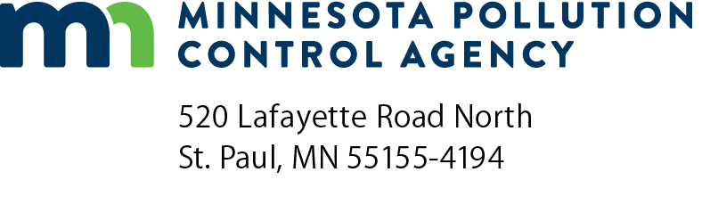 | Stormwater project plan  and plan supplement checklist  Stormwater Treatment Assistance Program  Minn. R. 7077.0277  Doc Type: Self Evaluation

Instructions: This form should be used by participants in the Clean Water Revolving Fund loan program to create a Stormwater Project Plan for submittal to the Minnesota Pollution Control Agency. This form can either be filled in directly and submitted, or it can be used as a reference to create a Stormwater Project Plan in a format of the participant’s choosing. The Stormwater Project Plan must be signed by a registered Professional Engineer in the state of Minnesota.
Project information
Applicant name: |  | Project number:
Project name: |  | *Project engineer:
*Stormwater Project Plan must be signed by a registered P.E. in the state of Minnesota.
Stormwater Project Plan content
Minn. R. 7077.0277, subp. 2a, A. - F.
A. | Current stormwater collection system:
 |  | Provide a complete description of the current stormwater collection system in the project service area:
 |  | Provide a complete description of the current stormwater treatment system (if existent) in the project service area:
 |  | Provide a complete description of the identified need in the project service area:
B. | Project service area – provide a complete description of the following:
 |  | The number of acres served
 |  | The estimated flow
 |  | A description of the watershed
C. | Project alternatives:
 |  | Provide a brief narrative describing the project alternatives that were considered:
 |  | Provide a description of how the proposed project was selected:
D. | Project description – provide a complete description of the following:
 |  | Location.
 |  | Best management practices to be implemented for the use of stormwater treatment.
 |  | Estimated construction costs.
 |  | Equipment replacement costs.
E. | Long-term maintenance plan – provide a complete description of the following:
 |  | Annual operation and maintenance costs.
 |  | Party responsible for performing maintenance activities.
 |  | Intended life span of any proposed stormwater treatment system.
F. | Reduction of pollutants
Provide an estimate of the reduction in pollutants.
Note: When applicable, the estimate must include any pollutants causing or contributing to the impairments in receiving waters.
Federal Water Pollution Control Act Sec. 602 (b) (13)
Submit a Cost and effectiveness certification form.
Stormwater Project Plan supplement
Minn. R. 7077.0277, subp. 3, A. - F.
A. | Environmental Information Worksheet (EIW)
 |  | Include a completed EIW.
B. | Public notice
Provide a complete list of addresses the commissioner will use for a 30-day public notice of a summary of the Environmental Information Worksheet.
Note: The addresses used for public notice purposes must be listed on a form prescribed by the commissioner
C. | Public hearing
 |  | Date of public hearing:
 |  | Provide a summary of the information presented and the public comments received at a public hearing (required under subp. 4):
 |  | Provide a summary of the action taken to address those comments:
D. | Formal resolution
 |  | A formal resolution of the municipality’s governing body adopting the Stormwater Project Plan.
 |  | Date of resolution adoption:
E. | Ordinances and intermunicipal agreements
 |  | Provide a list of ordinances and intermunicipal agreements necessary for the successful implementation and administration of the project:
F. | Certification
 |  | Provide a certification from the appropriate county or watershed management organization assuring that the Stormwater Project Plan is consistent with the comprehensive local water plan.

