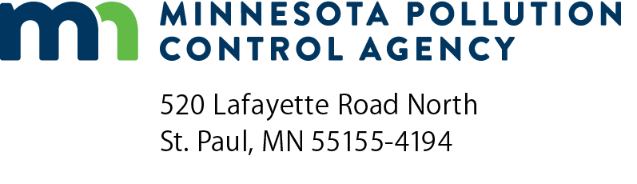 | Project schedule form  Stormwater Treatment Assistance Program  Minn. R. 7077.0279, subp. 3A  Doc Type: Project Schedule

Instructions: This form should be filled out and submitted to the Minnesota Pollution Control Agency by participants in the Clean Water Revolving Fund Loan Program or the Point Source Implementation Grant Program as part of the plans and specifications submittal for the proposed stormwater treatment system.
Project information
Municipality name:
Project number:
Schedule
Activity | Proposed completion date (Month/Year)
- Award construction contracts.
- Owner Issue notice to proceed with construction.
- If applicable, start date of construction on any type of stormwater related elements in the funding proposal.
- End construction.
- Project achieves final stabilization* as defined in the National Pollutant Discharge Elimination System Construction Permit; file Notice of Termination
*Final stabilization includes the following activities:
- All pervious surfaces must have uniform perennial vegetative cover approximately 70% established.
- Stormwater conveyance systems must be free of sediment.
- All permanent stormwater treatment systems must be brought back to the design grade and capacity.
- All temporary synthetic and structural erosion prevention and sediment control best management practices (such as silt fence) must be removed from the site.
- For construction projects on land used for agricultural purposes (e.g., pipelines across crop or rangeland), Final stabilization may be accomplished by returning the disturbed land to its preconstruction agricultural use
Authorized representative
Print name: |  | Title:
Signature: |  | Date (mm/dd/yyyy):

