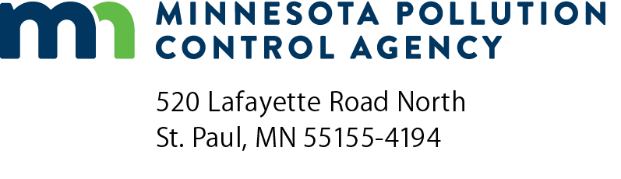 | Plans and specifications (P&S) and additional submittals checklist  Stormwater Treatment Assistance Program  Minn. R. 7077.0279

Instructions: This form should be used by participants in the Clean Water Revolving Fund Loan Program or the Point Source Implementation Grant Program to format a final set of plans and specifications for the proposed stormwater treatment system. The plans and specifications should be submitted to the Minnesota Pollution Control Agency.
Project information
Applicant name: |  | Project number:
Project name: |  | Project engineer:
Plans and specifications content
Minn. R. 7077.0279, subp.2, A.-F.
- Plans and specifications must be signed by a Professional Engineer registered in the state of Minnesota.
- A summary of design parameters for the stormwater treatment units.
- A summary of the stormwater treatment system flow conditions for:
Average design flow
Maximum design flow
- A stormwater pollution prevention plan to meet the construction stormwater permit requirements during the construction of the stormwater treatment systems.
- The latest detailed cost estimate, including operation and maintenance costs, based on the plans and specifications submitted.
- Administrative, bidding, and contract documents according to the applicable requirements under Minnesota Statues, including a 100% performance bond from the contractors.
Plans and specifications additional submittals
Minn. R. 7077.0279, subp.3, A.-C.
- A project schedule on a form prescribed by the commissioner.
- A certification from the municipality that states that:
A full-time resident inspection shall be provided during construction.
Written inspection reports, describing the construction inspected, construction problems, and the amount of inspection time required, shall be submitted to the commissioner on a monthly basis.
- Finalized and executed intermunicipal agreements necessary for the successful implementation and administration of the project.

