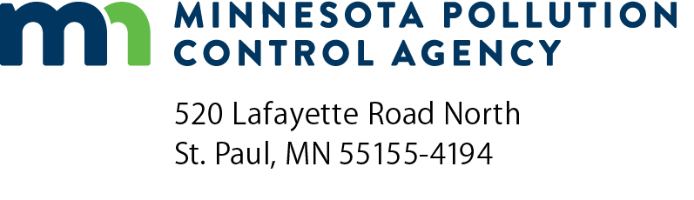 | One-year performance  certification report  Stormwater Treatment Assistance Program  Minn. R. 7077.0288  Doc Type: One Year Certification

Instructions: This form should be used by participants in the Clean Water Revolving Fund Loan Program or the Point Source Implementation Grant Program to create a certification report for submittal to the Minnesota Pollution Control Agency (MPCA) one year from the initiation of operation of the stormwater treatment system. This form can either be filled in directly and submitted, or it can be used as a reference to create a certification report in a format of the participant’s choosing. The initiation of operation of the stormwater treatment system is the date that the MPCA is notified in writing of the completion of the construction of the stormwater treatment system. This form must be signed by both the project representative and the professional engineer for the project.
Project information
 |  | Date of initiation of operation:
Applicant name: |  |  | Project number:
Project name: |  |  | Resident inspector:
Stormwater treatment performance certification submittals
Minn. R. 7077.0288, subp.2a, A.-B.
- A certification stating whether the project meets the following performance standards:
The project has been completed according to the approved stormwater project plan and the project is operating as intended.
State financial assistance money has only been used for work directly associated with stormwater treatment activities as described in the stormwater project plan.
All pipe outlets have been provided with permanent energy dissipation where the pipe’s outlet velocity exceeds the permanent cover’s erosive velocity
An operation and maintenance manual appropriate for the best management practices implemented during the project has been provided to the municipality by the project engineer.
One copy of “as-built” plans and specifications has been submitted to the commissioner in a format designated by the commissioner.
- Evaluation report:
An evaluation report describing the performance of the project as it pertains to the problems in need of correction identified in the stormwater project plan.
Describe:

Certification
We certify that the project meets the performance standards listed above.
Authorized representative |  |  |  |  |  | Professional Engineer
Print name: |  |  |  |  |  | Print name:
Organization: |  |  |  |  |  | Organization:
Signature: |  |  |  |  |  | Signature:
Date (mm/dd/yyyy): |  |  |  |  |  | Date (mm/dd/yyyy):

