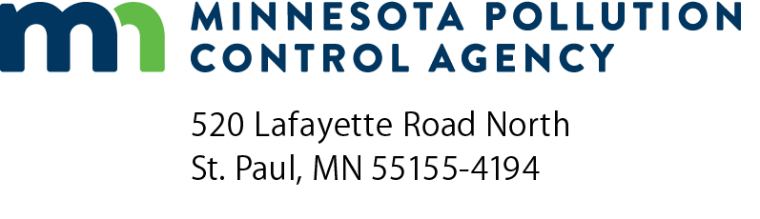 | Monthly inspection report form  Stormwater Treatment Assistance Program  Minn. R. 7077.0279  Doc Type: Self Audit

Instructions: This form should be used by participants in the Clean Water Revolving Fund Loan Program or the Point Source Implementation Grant Program to create an inspection report to be submitted to the Minnesota Pollution Control Agency once every month during active construction of the proposed stormwater treatment system. This form can either be filled in directly and submitted, or it can be used as a reference to create an inspection report in a format of the participant’s choosing.
Project information
 |  | Date of inspection:
Applicant name: |  | Project number:
Project name: |  | Resident inspector:
Inspection report content
Minn. R. 7077.0279, subp.3, B.
Provide a short narrative description of the construction activity that is going on and inspection time required (hours).
Provide a narrative description of the erosion and sediment control measures that have been installed on-site.
Provide a description of construction problems encountered and corrective actions taken to resolve them.
Provide photographic documentation of the control measures.

