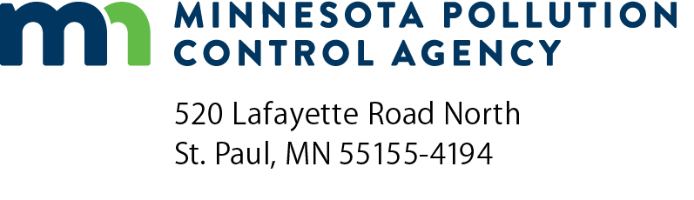 | Corrective action report checklist  Stormwater Treatment Assistance Program  Minn. R. 7077.0288

Instructions: This form should be used by participants in the Clean Water Revolving Fund Loan Program or the Point Source Implementation Grant Program to format a corrective action report if the One-year certification report indicates that the constructed permanent stormwater management system is not meeting the performance standards. The corrective action report should be submitted to the Minnesota Pollution Control Agency.
Corrective action report content
Minn. R. 7077.0288, subp.3
- Within 30 days of the performance certification date or within 30 days of the commissioner’s determination that the project does not meet the project performance standards, submit a corrective action report that includes:
An analysis of the project’s failure to meet the performance standards.
An estimate of the nature, scope, and cost of the corrective action necessary to bring the project into compliance with its performance standard.
A schedule for initiating, in a timely manner, the necessary corrective action work and for meeting the performance certification requirements following a start-up period that is reasonable for the type of corrective action work to be performed.
- Performance certification:
Following the completion of the corrective action work, submit a performance certification as specified under Minn. R. 7077.0288, subp. 2a, as applicable, according to the schedule in item A.

