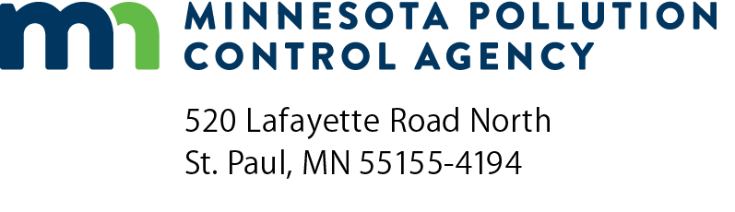 | CWRF administrative checklist for wastewater collection  and treatment projects  Clean Water Revolving Fund (CWRF) Program  Wastewater Projects  Minn. R. 7077
Instructions: This administrative checklist is used by Minnesota Pollution Control Agency (MPCA) staff engineers, project professional engineers, and municipal administrators to track administrative forms that will be submitted for a project and the project progress to completion (aka, Notification of satisfactory performance to PFA).
Note: Complete Section A for a Planning Project, Section B for a Design Project, or Section C for a Construction Project. Enter the date (mm/dd/yyyy) submitted or completed on the line.
Municipality name: |  | MPCA Engineer:
Project number: |  | Consulting Engineer:
 | Submit PPL request forms (7077.0115) | Total points:

Section A
Planning Projects, Submit Certification Request (Minn. R. 7077.0280, subp. 2)
Submit a description of scope of work and costs leading to an approved facilities plan.
Submit a schedule of completion of the facilities plan form.
(ISTS only) Submit a copy of draft ordinance that adopts Minn. R. ch. 7080.
MPCA Certification of Planning Project to PFA (Minn. R. 7077.0281, subp. 1)

Section B
Design Projects, Submit Certification Request. (Minn. R. 7077.0280, subp. 2).
Submit a schedule for completion of plans and specs.
(ISTS only) Submit a copy of draft ordinance that adopts Minn. R. ch. 7080.
MPCA Certification of Design Project to PFA. (Minn. R. 7077.0281, subp. 1)

Section C
Facilities Plan Submittal (7077.0272)
Facilities Plan supplemental information submittal (Minn. R. 7077.0272, subp. 2a.)
Submit SERP mailing list form.
Submit a summary of the information presented at a Public Hearing.
Submit formal resolution of adoption.
Submit a list of ordinances or intermunicipal agreements needed to complete project.
Submit signed treatment agreements with any SIU.
Submit an EIW (or EAW if appropriate) form.
Submit CWRF cost and effectiveness checklist
Submit B3 SB 2030 exemption form (Minn. Stat. § 218B.241, sub. 1-10 and 16B, sub.1-4)
Submit CWRF cost and effectiveness certification form [FWPCA Sec. 602(b)(13)]

 | MPCA Facilities Plan Preliminary Approval
 | PFA places project on IUP
 | MPCA Completion of Environmental Review process. (ES or EAW?)
 | MPCA Issues Permit. (NPDES, SDS, or Sewer Extension?)
 | MPCA Facilities Plan Final Approval
 | Plans and Specifications Submittal. (Minn. R. 7077.0274)
 | Additional submittals. (Minn. R. 7077.0274, subp. 3)
 |  | Submit Project schedule form.
 |  | Submit a certification that full-time inspection will be performed.
 |  | Submit a certification that monthly written construction reports will be submitted.
 |  | Submit a copy of any finalized and executed intermunicipal agreements.
 |  | Essential project components: |  | % | (Minn. R. 7077.0281, subp. 3a.)
 | MPCA Plans and Specifications Approval.
 | Construction project certification submittals received. (Minn. R. 7077.0280, subp. 4)
 |  | Submit a Certification of enactment of sewer use/sewer rate ordinance form.
 |  | (ISTS only) Submit a certification that municipality has enacted and enforces an ordinance that adopts Minn. R. ch. 7080, prohibits discharge from nonresidential structures, and establishes a maintenance plan.
 | MPCA Certification of Construction Project to PFA. (Minn. R. 7077.0281, subp. 3)
 | Submit evidence of certified operator. (60 days prior to initiation of operation.) (Minn. R. 7077.0286)
Submit an O&M Manual or O&M Manual certificate of completion form.
(60 days prior to initiation of operation.) (Minn. R. 7077.0286)
 | MPCA completes Prefinal Inspection. (Minn. R. 7077.0286, subp. 2)
 | MPCA approves Initiation of Operation. (Start of one-year performance period) (Minn. R. 7077.0286)
 | MPCA completes Final Inspection. (Minn. R. 7077.0286, subp. 4)
 | One-year performance certification documents submittal. (Minn. R. 7077.0288)
 |  | Submit a One-year certification form.
 |  | Submit one copy of as-built plan and specifications on microfiche.
 |  | Submit a revised O&M manual or revised O&M Manual certificate of completion form.
 |  | Submit a Documentation of sufficient funds (are being collected) form.
 |  | If necessary, submit a corrective action report.
 | MPCA Notification of satisfactory performance to PFA. (Minn. R. 7077.0290)
Acronyms
EAW Environmental Assessment Worksheet
EIW Environmental Information Worksheet
ES Environmental Summary
ISTS Individual Sewage Treatment System
IUP Intended Use Plan
MPCA Minnesota Pollution Control Agency
NPDES National Pollutant Discharge Elimination System
O&M Operation and Maintenance
PFA Public Facilities Authority
SDS State Disposal System
SERP State Environmental Review Program
SIU significant industrial users

