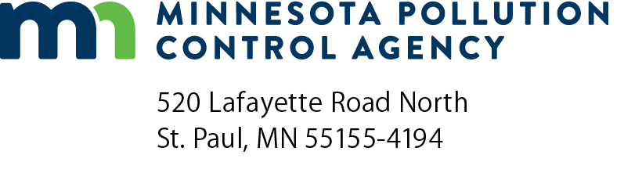 | Project Priority List (PPL)  Stormwater Application

1. | Applicant name:
 | Project area:
 | Town/city:
 | Population:
 | County:
2. | Contact person:
 | Address:
 | Phone:
 | Email:
3. | Project consultants/Firm name (if applicable):
 | Contact name:
 | Address:
 | Phone:
 | Email:

4. | Need or problem project addresses: | Yes/No | Short description
 | a. A water quality need? | Yes No
 | b. A water quantity need? | Yes No
 | c. Permanent stormwater treatment structures? | Yes No
 | d. Permanent infiltration techniques? | Yes No
 | e. Treatment structure designs based on accepted engineering practices? | Yes No
Note: Required attachments for stormwater treatment projects. A map of the project service area which has an identifiable scale and identifies all existing and proposed stormwater structures and receiving waters.
5. New project / Update to existing PPL project: |  |  |  |  | New project Update to existing project Rescore
 |  |  |  | MPCA Project number:
6. | Project description:
7. | Project estimated cost:
8. | Current project status:
9. | Desired construction start date if financing is available (month/year):
10. | Plans and specifications submitted along with PPL Application? Yes No
11. | Please indicate if this project may qualify for Green Project Reserve (GPR), and has potentially eligible components, or if the entire project is applying to be determined GPR eligible.
 | The U.S. Environmental Protection Agency (EPA) provided a guidance document listing examples of projects that will qualify for Green Project Reserve dollars. Below is an abbreviated list of those examples. If the proposed project matches one or more of the examples, check the box next to the example that describes the project. For more information, see Guidance for Green Project Reserve at https://www.pca.state.mn.us/business-with-us/apply-for-financial-assistance
Categorical eligible project types
1. Water Efficiency
2. Energy Efficiency
3. Green Infrastructure
4. Environmentally Innovative Projects
5. Non-categorical (describe)
On behalf of an eligible project as their authorized authority, I hereby submit this application for placement on the PPL:
Print Authorized Representative Name: |  |  |  |  | Signature:
Title: |  |  |  |  | Date (mm/dd/yyyy):
Email:
Submit to: ppl.submittals.pca@state.mn.us

For more information, contact:
Bill Dunn, Clean Water Revolving Fund Coordinator at 651-757-2324 or bill.dunn@state.mn.us
https://www.pca.state.mn.us/business-with-us/apply-for-financial-assistance

