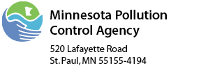 | State Revolving Fund  Certification of Enactment of Sewer  Use/Rate Ordinance Form  Minnesota Rules 7077.0280, Subp. 4.B.

Municipality Name:
Project Number:

A sewer use ordinance or a combined sewer use/rate ordinance has been enacted that at a minimum:
- prohibits new inflow connections to be added to the wastewater treatment system;
- requires new sewers and connections to be properly designed and constructed; and
- prohibits toxics and other pollutants to be placed in the municipal wastewater treatment system in amounts or concentrations that endanger public safety or the physical integrity of the treatment system or cause exceedance of permit limitations.

Certification

Print Authorized Representative Name: |  |  |  | Title:
Signature: |  |  |  | Date:

