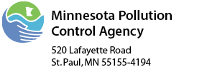 | State Revolving Fund  Project Schedule Form  Minnesota Rules 7077.0274, Subp. 3.A.

Municipality Name:
Project Number:

 |  | Proposed Completion Dates
ACTIVITY |  | Treatment  System  (Month/Year) | Collection System (Month/Year)
1. | Award Construction Contracts
2. | Issue Notice to Proceed with Construction
3. | Collection System and All Connections Complete
4. | Initiate Facilities Operation
5. | Municipality Submits a One-year Certification Form stating that the project conforms to the approved plans and specifications and meets the permit effluent limitations (12 months from initiation of operation).

Print Authorized Representative Name: |  |  |  | Title:
Signature: |  |  |  | Date:

