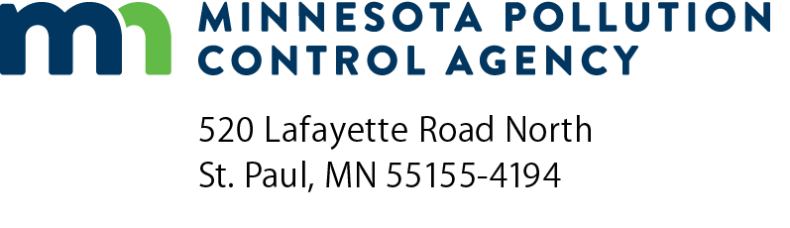 | LSTS process control monitoring for nitrogen  NPDES/SDS Permit Program  Large Subsurface Treatment Systems (LSTS)  Doc Type: Monitoring Results

Instructions: Use this form to record the nitrogen process control monitoring results required in your State Disposal System (SDS) permit. Samples shall be taken at a minimum frequency of once per week at a location following nitrification and prior to denitrification. Maintain this data at the treatment facility for a minimum of three years. These samples are not required to be analyzed by a certified laboratory or comply with 40 CFR pt. 136, but testing for these parameters should conform to the monitoring equipment manufacturer’s recommendations for use and accuracy. Monitoring equipment is available in various formats, such as test strips, color disc, colorimeter, pen, etc. Contact your laboratory equipment vendor for assistance.

Facility information
Facility name:
Permit number: |  |  | Sampling location:

Weekly monitoring results
Date (mm/dd/yyyy) | Name | Time | Ammonia (mg/L) | Nitrate (mg/L) | Alkalinity (mg/L) | Dissolved oxygen (mg/L) | Temperature (°C) | pH (SU)
Ex: 6/10/2017 | John Doe | 12:00 pm | 12.7 | 20.9 | 123 | 2.9 | 5.3 | 7.9
Operating level goal |  |  | <1 mg/L |  | >100 mg/L | >2 mg/L | > 7 deg C | 6.8 – 8.0
Comments:

