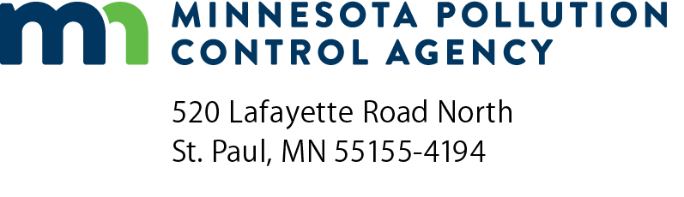 | WTP subsurface disposal system  weekly observations form  NPDES/SDS Permit Program  National Pollutant Discharge Elimination System (NPDES)/State Disposal System (SDS)  Doc Type: Monitoring Results
Instructions: Use this form to record the weekly observations of the water treatment plant (WTP) subsurface disposal system(s) required in your SDS Permit. Submit this form as an attachment to the Discharge Monitoring Reports. Maintain this data for a minimum of three years.
Facility information
Facility name: |  | Permit number:

Weekly observations – for month of: |  | Year:

Monitoring station name  Example: WS001, well 2, etc. | Monitoring station: |  |  |  |  | Monitoring station: |  |  |  |  | Monitoring station:
Week of the month | 1st | 2nd | 3rd | 4th | 5th | 1st | 2nd | 3rd | 4th | 5th | 1st | 2nd | 3rd | 4th | 5th
- Date of observation (mm/dd/yy):
- Time of observation (00:00 am/pm): | am pm | am pm | am pm | am pm | am pm | am pm | am pm | am pm | am pm | am pm | am pm | am pm | am pm | am pm | am pm
- Name of observer:
- Ponding (depth):
- Vegetation  (% of coverage, type): | % | % | % | % | % | % | % | % | % | % | % | % | % | % | %
- General condition (erosion, etc.):
Comments:

