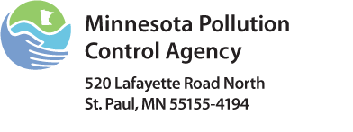 | Industrial Chemical Additives Attachment  NPDES/SDS Permit Program  Doc Type: Permit Application

The National Pollutant Discharge Elimination System (NPDES)/State Disposal System (SDS) Permit Program regulates wastewater discharges to land and surface waters. This is an attachment to the Industrial Applications for facilities with multiple chemical additives.

Complete the attachment by typing or printing in black ink. Attach additional sheets as necessary. For more information, please contact the Minnesota Pollution Control Agency (MPCA) at: In Metro Area: 651-296-6300 or Outside Metro Area: 800-657-3864.
Permittee name: |  | Permit number: | MN

Chemical | Purpose | Location of chemical addition in process  (e.g., to raw water supply, at greensand filter, before RO unit #2, etc.) | Amount/duration/frequency of addition  (i.e., continuous or slug dosing. If slug dosing give amount/duration and frequency of addition; e.g., slug dosing 13.5 gal/3hours, once every two weeks) | Average rate of use  (weight or volume per day) | Maximum rate of use  (weight or volume per day)
*Remember to attach the Material Safety Data Sheets, complete product labels and any other information on chemical composition, aquatic toxicity, human health, and environmental fate for each chemical additive.
Please make a copy for your records.
Refer to the Transmittal Form for mailing instructions.

