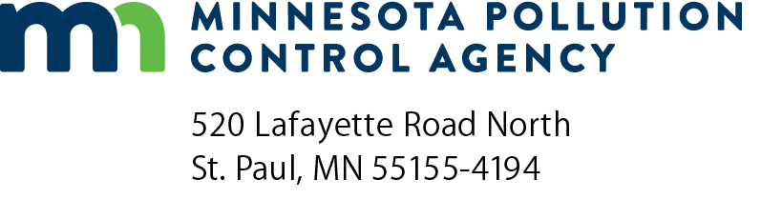 | Individual Industrial Stormwater  Site Inspection form  NPDES/SDS Wastewater Permit Program  Doc Type: Annual Compliance Report
Instructions: This inspection form is intended to meet the requirements listed in the Industrial Stormwater chapter of your National Pollutant Discharge Elimination System (NPDES)/State Disposal System (SDS) Permit. Inspections shall be conducted at the frequency indicated within your individual permit. See the Inspection and Maintenance section of the Industrial Stormwater chapter of your permit for specific inspection requirements. Inspection results and documentation shall remain on site whenever Permittee staff is available on the site and be available upon request.
Facility Information
Facility name: |  |  |  |  |  |  |  |  |  |  | Date (mm/dd/yyyy):
Facility address: |  |  |  |  |  |  |  |  |  |  | Time of inspection:
City: |  |  |  |  |  |  | State: |  |  |  |  | Zip code:
Site contact name: |  |  |  |  |  |  | Inspector name:
SIC Category: |  |  |  |  |  |  | Runoff event: |  |  | Yes No
Permittee name (if different from facility name):
Permit number: |  |  |  |  |  |  | Weather:
Narrative activity and/or SIC Code(s):
Inspector Information
Name: |  | Inspection number:
Describe duties being performed below:
Trained for these duties: Yes No
Have the following areas been inspected at your facility?
a. | Bulk storage areas (tanks, drums, fuels, pallets, etc.) Yes No  Describe findings:
 | Actions needed:
b. | Waste disposal areas Yes No  Describe findings:
 | Actions needed:
c. | Maintenance areas (includes vehicle fueling) Yes No  Describe findings:
 | Actions needed:
d. | Loading/Unloading/Material Transfer areas Yes No  Describe findings:
 | Actions needed:
e. | Raw material, intermediate product, by-product and final storage areas Yes No  Describe findings:
 | Actions needed:
f. | Other areas required by your permit: |  | Yes No
 | Describe findings:
 | Actions needed:
Note: Areas described in a-f (above) should be inspected in every inspection.
Best Management Practices (BMP) Evaluation (Stormwater Control Measures)
Evaluate all structural and non-structural BMPs to determine whether they are properly functioning. If they are not, follow the permit requirements for repair/replacement and document in the SWPPP.
BMP type | Function | Condition/What Repairs Needed

New Materials and Activities
Describe below any newly exposed materials and activities since the last inspection. Be sure that these materials are documented with appropriate BMPs in the Stormwater Pollution Prevention Plan (SWPPP).
Materials and activities | Date exposed (mm/dd/yyyy)
Runoff Event Inspection
Was the runoff inspection conducted during a storm event? Yes No
For the inspection conducted during a runoff event, it is important to visually inspect discharges (runoff) for contaminants (sheen, rusty color, milky or translucent, sediment/muddy, etc.). Describe the discharges that you observed below:

Discharges observed (Y/N) | Describe discharges (color, transparency, volume, etc.)
Yes No
Yes No
Yes No
Yes No

What changes have been made to clean up these discharges:
Oil and Grease Inspections
Is this facility required to inspect for oil and grease sheen? Yes No
Was the inspection conducted during a snowmelt event? Yes No
Results from oil and grease inspection:

