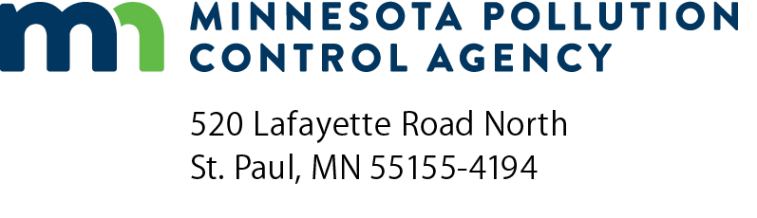 | Regulatory Certainty  checklist  NPDES Permit Program  National Pollutant Discharge Elimination System (NPDES)  Doc Type: Application/Approvals
Purpose: The 2016 Legislature provided the Minnesota Pollution Control Agency (MPCA) with the authority to offer a unique incentive to municipalities to employ advanced treatment technology capable of treating nutrients in waste streams. Under this incentive called Regulatory Certainty, the MPCA will impose no more restrictive effluent limitations for nitrogen and phosphorus when biological nutrient removal (BNR) systems are employed in wastewater treatment for a period of 20 years, or the expected design life of the facility.
To take advantage of Regulatory Certainty, municipalities must design and construct, or demonstrate that an existing facility can be operated as a BNR treatment plant. Once certified as BNR by MPCA reviewing engineers, the municipality will enter into a negotiated agreement with MPCA; and for a period of 20 years (or the design life), the municipality will have assurance that the established nitrogen and phosphorus limitations will not be reduced.
Instructions: Submit a completed application along with a copy of plans and specifications for the proposed BNR system. The application, as well as plans and specifications will be reviewed by the MPCA to examine the facility’s ability to treat for phosphorus and nitrogen, and certify the BNR facility for purposes of the Regulatory Certainty Program.
Regulatory Certainty process checklist
Eligibility
Permittee is installing biological nutrient removal (BNR) system on a voluntary basis
Must be capable of meeting the assigned water quality-based effluent limit for phosphorus
Proposed BNR system is capable of meeting a total nitrogen effluent limit of 10 mg/L to be classified as BNR
- Limit type will be a mg/L calendar monthly average
Construction submittal/permitting process
Request placement on the Project Priority List (PPL)*
Apply for Point Source Implementation Grant (PSIG)*
Submit Facility Plan*
- Pilot testing may be necessary to determine final sizing of treatment components.
- Based on the PSIG application and description in the facility plan, the MPCA will determine if the project is eligible for Regulatory Certainty. This will be documented in the facility plan preliminary approval letter.
Submit permit application (submitted concurrently with plans and specifications):
- 10 mg/L total nitrogen calendar month average effluent limit will be included in the permit **
- Water quality based effluent limit for phosphorus will be included in the permit
- Construction schedule will be included in the permit establishing a timeframe for completion of construction (typically within three years)
Submit plans and specifications that include the following*** (submitted concurrently with permit application):
- Design checklist, as appropriate
- System must be capable of complete nitrification
- Influent characteristics well defined and accounted for in design, including variability in flow rates and loading
- Biosolids production and sidestream flows must be accounted for and included in the design
- Detention times in the anoxic and anaerobic tanks need to consider flow rates and loading during the entire design life of the facility
- Short circuiting of all tanks and back mixing of aeration tanks shall be considered and accounted for in the design
- Chemical feed locations
- Describe the required process control in detail
- Show that Permittee has the budget and staffing to perform process control
Execute Regulatory Certainty Agreement between Permittee and the MPCA
- Permittee and the MPCA will meet to establish the conditions of the Agreement. The Agreement will address the timeframe between permit issuance and initiation of operation (the start of the Regulatory Certainty).
Permit issued
- Permit includes total nitrogen and total phosphorus limits, construction schedule, and Agreement (as an appendix)
The Regulatory Certainty timeframe starts at initiation of operation. The length of Regulatory Certainty is equal to the expected design life of the facility or 20 years, whichever is shorter. ****
* Only for new construction projects
** EPA 1993 Nitrogen Control Manual and Metcalf and Eddy fifth edition used to justify the use of 10 mg/L total nitrogen as the achievable limit for BNR. Limits lower than 10 mg/L may require additional treatment and limits higher than 10 mg/L may be achievable with conventional activated sludge.
*** As with any plans and specifications, the MPCA will only approve the plans and specs after the permit is issued and there is reasonable assurance that the treatment system, when constructed, will comply with regulations and criteria of the MPCA.
**** Design life of the facility will be calculated based on the expected remaining life of each treatment component including equipment weighted to the replacement cost at the start of Regulatory Certainty.

