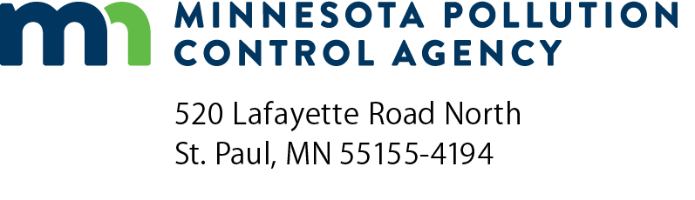 | Regulatory Certainty  application  NPDES Permit Program  National Pollutant Discharge Elimination System (NPDES)  Doc Type: Application/Approvals
Purpose: The 2016 Legislature provided the Minnesota Pollution Control Agency (MPCA) with the authority to offer a unique incentive to municipalities to employ advanced treatment technology capable of treating nutrients in waste streams. Under this incentive called Regulatory Certainty, the MPCA will impose no more restrictive effluent limitations for nitrogen and phosphorus when biological nutrient removal (BNR) systems are employed in wastewater treatment for a period of 20 years, or the expected design life of the facility.
To take advantage of Regulatory Certainty, municipalities must design and construct, or demonstrate that an existing facility can be operated as a BNR treatment plant. Once certified as BNR by MPCA reviewing engineers, the municipality will enter into a negotiated agreement with MPCA; and for a period of 20 years (or the design life), the municipality will have assurance that the established nitrogen and phosphorus limitations will not be reduced.
Instructions: Submit a completed application along with a copy of plans and specifications for the proposed BNR system. The application, as well as plans and specifications, will be reviewed by the MPCA to examine the facility’s ability to treat for phosphorus and nitrogen, and certify the BNR facility for purposes of the Regulatory Certainty Program.
Permittee information
Permittee name: |  | Permit number:
Facility information
Mailing address:
City: |  |  |  |  |  |  |  |  | State: |  |  |  |  |  | Zip code:
Phone: |  |  |  |  |  | Fax: |  |  |  | Email:
Average Wet weather design flow: |  |  |  |  |  |  |  | million gallons per day (mgd)
Receiving water name:
What concentration of total nitrogen is the BNR facility designed to treat: |  |  |  |  |  |  |  |  |  |  |  |  |  | milligrams per liter (mg/L)
What concentration of total phosphorus is the BNR facility designed to treat: |  |  |  |  |  |  |  |  |  |  |  |  |  |  |  | mg/L
BNR process configuration (please select one):
Modified Ludzack-Ettinger (MLE) Process | A²/O Process
Bardenpho Process (Four-Stage) | Modified Bardenpho Process
Sequencing Batch Reactor (SBR) Process | Modified University of Cape Town (UCT) Process
Oxidation ditch | Other (specify):

