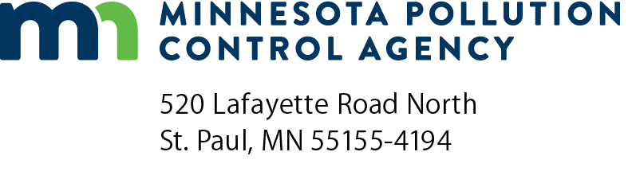 | County SSTS grant application  FY24 Subsurface Sewage Treatment Systems  (SSTS) Program  Clean Water Legacy Act (Minn. Stat. ch. 114D)  Doc Type: Evaluation/Selection
Application due date (received in MPCA offices via email): August 18, 2023 by 4:30 p.m.

The Minnesota Pollution Control Agency (MPCA) is seeking grant applicants to support work of the Clean Water Legacy Act (Minn. Stat. ch. 114D) in protecting groundwater and surface water from impacts resulting from the improper design and/or operation of Subsurface Sewage Treatment Systems (SSTS).
Submittal: Save the form to your computer and email the completed form to ssts.projects.mpca@state.mn.us. If you do not receive an email confirmation receipt within two business days or if you have questions, please send an email to the same address at ssts.projects.mpca@state.mn.us.
The MPCA is pleased to offer grants to counties for administration of SSTS programs and to assist low-income homeowners with needed SSTS upgrades. The SSTS base grant is for counties that administer an SSTS program, which requires having an SSTS ordinance that complies with state rules (includes all required provisions and includes 2011 provisions for systems over 2,500 gallons per day) and submitting a 2022 annual report. No application is needed to receive the base grant. The MPCA reviews eligibility and provides the grant to all eligible counties. This year the base grant will be $21,200 per county.
This grant application specifically covers the SSTS low-income fix-up grant. This year there is a total of $1.8 million available to counties. The MPCA will determine grant allocations based on review of applications; funds will be distributed to counties through the Board of Water and Soil Resources (BWSR) Natural Resources Block Grants (NRBG) in fall of 2023.
SSTS low-income fix-up grants
These grants will be awarded to counties for upgrading eligible SSTS (Notice of Noncompliance issued; may be Imminent Threat to Public Health or Safety or Failing to Protect Groundwater). Grants may be awarded without a list of specific noncompliant SSTS or properties and may be held by the county for the duration of the grant period. Funds must be spent by December 31, 2027. Grant awards have no maximum and distributions may be reduced if the total of all county requests exceeds the total low-income fix-up grant funds available. Request only as much money as can be utilized by the above fund spend date. Also, please keep in mind, this is an annual distribution and additional funding can be applied for in future fiscal years. Progress on work relating to the SSTS low-income fix-up grant will be reported through BWSR’s eLINK system.
- Counties that seek these funds commit to using the following criteria in determining grant eligibility for specific projects:
- Fix SSTS that have been deemed Failing to Protect Groundwater or an Imminent Threat to Public Health or Safety (must have been issued a Notice of Noncompliance).
- Funding can only be used for homesteaded single-family homes or duplexes.
- Homeowner must be low-income.
- Recommend use of a sliding scale for grant funds based on income.
- Funds must be used for eligible SSTS upgrades or returned to the state if not expended by December 31, 2027.
- Other considerations:
- Counties may use a portion of funds for work directly related to, and necessary for, administering the grants as approved in the grant award. This amount must not exceed the lesser of $4,000 or 10% of the distribution received.
- Preference in awarding grants will be given to:
    - Counties with no unspent SSTS low-income fix-up grant funds (Detail will be requested on county plans for any unspent funds.)
    - Counties with the greatest proportion of impaired water body assessment units (AUID) impaired for E. coli, nutrients, or fecal coliform from all applicants. Determined from MPCA’s inventory of impaired waters.
    - Counties that administer active programs to identify and address noncompliance
    - Counties with the lowest average annual income
- Grant awards will be reduced if the requests exceed the amount of grant funds available.

Amount requested* : | $ | Amount proposed for grant administration (lesser of $4,000 or 10%): |  |  | $
*Request only how much money that can reasonably be utilized by December 31, 2027
Estimated number of upgrades that will be completed:
Counties applying for low-income fix-up funds must answer whether or not they have received low-income fix-up funds in previous years (Question 1). If you answer yes to Question 1 then Questions 2 thru 6 must be completed for that calendar year.

 | Question 1 | Question 2 | Question 3 | Question 4 | Question 5 | Question 6
Calendar Year (Fiscal Year)  Funds Expiration Date | Did your county receive Low- income fix-up funds in: (Must answer yes or no) | How much money did your county receive: | How much money has not yet been allocated to specific projects: | Have you received an extension through BWSR for any unallocated funds: | If yes to Question 4, when does the extension expire: | How much unallocated money was returned to BWSR:
2019 (FY20)  Expired 12/31/2022 | Yes No | $ | $ | Yes No |  | $
2020 (FY21)  Expired 12/31/2022 | Yes No | $ | $ | Yes No |  | $
2021 (FY22)  Expires 12/31/2024 | Yes No | $ | $ | Not applicable | Not applicable | Not applicable
2022 (FY23)  Expires 12/31/2024 | Yes No | $ | $ | Not applicable | Not applicable | Not applicable
Certification (required)
Yes - I certify under penalty of law that the appropriate person(s) have executed the grant application on behalf of the county as required by the county’s applicable articles, bylaws, resolutions, or ordinances.
By typing my name in the following box I certify the above statements to be true and correct, to the best of my knowledge, and that this information can be used for the purpose of processing my application.
County Official responsible for Grant
Name: |  |  |  | County name:
 | (This document has been electronically signed.) |  |  | Watershed(s) impacted by work:
Title:
Date (mm/dd/yyyy): |  |  |  | Local agency responsible:

Submittal: Save the form to your computer and email the completed form to ssts.projects.mpca@state.mn.us. If you do not receive an email confirmation receipt within two business days or if you have questions, please send an email to the same address at ssts.projects.mpca@state.mn.us.

