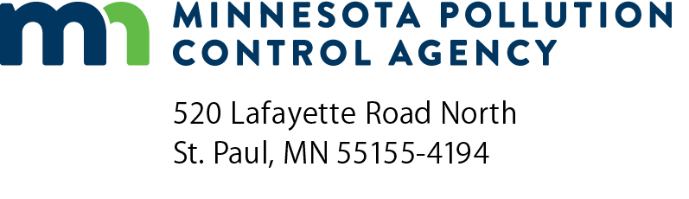 | Industrial Stormwater Pollution Prevention Plan (SWPPP) checklist  NPDES/SDS Industrial Stormwater Permit  Doc Type: Permitting Checklist

Purpose: A Stormwater Pollution Prevention Plan (SWPPP) must be written before a facility can apply for and receive an industrial stormwater permit. Use this checklist to make sure a completed SWPPP contains the required information. A template for creating a SWPPP is available on the Minnesota Pollution Control Agency (MPCA) website at https://www.pca.state.mn.us/business-with-us/step-4-create-swppp-choose-bmps.
SWPPP template section | SWPPP requirements | Part of permit with more info | Yes | No | N/A
 | The SWPPP was completed before the permit application was submitted to the MPCA. | Part I, 4.2
 | The SWPPP is kept at the facility and can be made available for review within 72 hours of a request. | Part III, 37.2
1 | Individuals are listed who are responsible for: managing the SWPPP and BMPs, conducting inspections, collecting samples, submitting reports, training employees and paying the annual fee. | Part III, 28.2 D & G
2 | There is a place to record updates to the SWPPP. | Part III, 36.2
3 | Facility description includes a description of facility activities, total acreage and acreage of industrial activities and materials. | Part III, 30.2
4 | Facility map is included, with all applicable parts included. | Part III, 31.2
5 | Sector-specific requirements listed in Part VIII of the permit have been included. | Part III, 28.2 F, Part VIII
6 | Activities and materials that could come in contact with stormwater have been inventoried; possible pollutants are documented. | Part III, 33.2, 34.2
6 | Best management practices (BMPs) to reduce or eliminate stormwater pollution from the facility have been identified and are described (structural or nonstructural). | Part II
7 | There is a place to record inspections or attach completed inspection forms. | Part III, 28.2 H
8 | There is a place to record maintenance of BMPs. | Part III, 28.2 I
9 | Non-stormwater discharges are documented and all prohibited discharges are eliminated. | Part II, 23.2
10 | An equipment preventative maintenance program is included or attached. | Part II, 22.2
11 | A spill response and prevention procedure is included or attached. | Part II, 24.2
12 | Information about the employee training program is included or attached. | Part II, 26.2-26.4
13 | If applicable: Mercury Minimization Plan is included or attached. | Part II, 25.2
14 | If applicable: PFAS sampling and reporting requirements, if your facility has a primary SIC Code listed in Appendix D of the industrial stormwater permit. | Part XI
15 | If applicable: Section for mobile industrial activities is included and kept at the mobile locations. | Part III, 28.2 E

