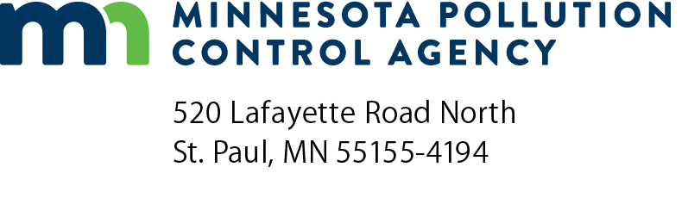 | Industrial Stormwater  Monthly Site Inspection Form  NPDES/SDS Industrial Stormwater Permit Program  Doc Type: Self-Audit
Instructions: Use this form to document the monthly stormwater inspections required in the Minnesota Pollution Control Agency (MPCA) Industrial Stormwater Permit (MNR053000). At minimum, one stormwater inspection is required each calendar month. Inspections during rain and snowmelt runoff events are required at least one time per calendar year or two times per calendar year depending on the industrial sector identified in your permit application. Please review your permit to determine specific inspection requirements and required frequencies.
Facility information
Facility name:
Facility address:
City: |  |  | State: |  | Zip code:
Inspector information
Inspector name: |  |  | Date and time:
Weather:
Inspector has been trained to do inspections: Yes (required)
Have the following areas been inspected at your facility?
a. | Bulk storage areas (tanks, drums, fuels, pallets, etc.) Yes No  Describe findings:
 | Actions needed:
b. | Waste storage and disposal areas Yes No  Describe findings:
 | Actions needed:
c. | Maintenance areas Yes No  Describe findings:
 | Actions needed:

d. | Loading/unloading or shipping/receiving areas Yes No  Describe findings:
 | Actions needed:
e. | Raw material, intermediate product, by-product and final product storage areas Yes No  Describe findings:
 | Actions needed:
Evaluate stormwater management methods
Evaluate each of the stormwater management methods (also called Best Management Practices or BMPs) that you developed for your Stormwater Pollution Prevention Plan (SWPPP). If changes or repairs are needed, make them within seven calendar days and record them in your SWPPP. If the work cannot be done in seven calendar days, put backup methods in place.
Management method | Describe changes or repairs needed | Changes and repairs recorded in SWPPP?
 |  | Yes No
 |  | Yes No
 |  | Yes No
 |  | Yes No
 |  | Yes No
 |  | Yes No
 |  | Yes No
 |  | Yes No
New materials and activities
Describe any materials or activities that are newly exposed to rain, snow, snowmelt, or other runoff since the last inspection. Either move them indoors, or come up with a way to minimize exposure and add it to the management methods section of your Stormwater Pollution Prevention Plan.
New material or activity exposed to stormwater | Choose one:
 | Moved indoors Added to SWPPP
 | Moved indoors Added to SWPPP
 | Moved indoors Added to SWPPP
 | Moved indoors Added to SWPPP
Runoff Inspection
Each year, you must complete monthly inspections when there is runoff from rain or snowmelt. Please see your permit for specific frequency requirements. Visually inspect the runoff for evidence of pollutants. For example, the runoff may have an oily sheen or be rusty, milky, muddy, etc.
Did you conduct a runoff inspection as part of today’s inspection? Yes No
Runoff was from: Snowmelt Rain
Describe the runoff (color, transparency, amount, etc.)
If evidence of pollutants is found, what changes will you make to clean up the runoff, and when will you make the changes?
Oil and grease runoff inspection (if applicable)
Certain industries must do at least two of their 12 monthly inspections when there is runoff from rain or snowmelt and inspect the runoff for grease or oil sheens. One runoff inspection must be during snowmelt.
Does your industry have to do two oil and grease runoff inspections annually?  (See Part VII, Sector-specific requirements of the permit) | Yes (continue)  No
Did you conduct a runoff inspection as part of today’s inspection? | Yes (continue)  No
Runoff was from: | Rain  Snowmelt
Was this the first or second runoff inspection for the calendar year? | 1st  2nd
Was there an oily sheen? | Yes  No
If yes, have you come up with a management method to prevent the oil or grease from contacting stormwater and added it to the management methods section of your SWPPP? | Corrective action taken:
Per-and Polyfluoroalkyl Substances (PFAS) (if applicable)
This section is intended for use by facilities with a primary SIC Code listed in the 2025 NPDES/SDS Industrial Stormwater Permit’s Appendix D.

- During the last month has the facility been evaluated to determine whether there are new exposed materials or activities that may include PFAS over the last month? | Yes (continue to B)  No (continue to C)
- During the last month were any new Area(s) of Concern (AOC) identified and added to the facility’s PFAS monitoring plan as a result of the evaluation? (Addition of a new AOC requires a permit modification application.) | Yes  No
- During the last month has the facility’s AOC(s) been visually inspected to determine if sampling should have been performed? | Yes  No
- Has the facility been required to complete a SERP and have the SERP activities been implemented this month? | Yes  No
File this completed inspection with your SWPPP.

