Nutrient Reduction Strategy

August 2020

Appendix B:
External Factors Affecting Nutrients in Water
5-year Progress Report on
Minnesota’s Nutrient Reduction Strategy

Appendix B. External Factors Affecting Nutrients in Water
Written by Dave Wall of the MPCA in association with Minnesota’s Nutrient Reduction Strategy 5-year Progress Report (2020)
Many external factors outside of management choices influence nutrient delivery to waters over time, including changes in population, climate, land use, river flow, and others. The ability to control these external factors vary. Together these external factors can either increase or decrease the expected nutrient reductions in waters and, as a result, have the potential to overshadow the effectiveness of adopted Best Management Practices (BMPs) in reducing nutrients.
Understanding the influence of external factors on water nutrient trends provides important context for comprehensively and objectively evaluating overall progress toward NRS milestones and goals, and may help inform decisions about future NRS implementation approaches. This section includes a summary of recent changes in certain external factors and how they generally can influence nutrient loads.

Population
Human population influences the amount of wastewater generated and can also have an effect on development that increases impervious surface cover and associated stormwater runoff. According to the Minnesota State Demographic Center, Minnesota’s population reached 5,629,416 in 2018, an increase of 6.1% since 2010. The Twin Cities Metropolitan area experienced a majority of this population increase; over half of the counties in out-state Minnesota experienced a decrease in population.
In addition to human population, changes in livestock and poultry populations can affect manure generation. More livestock and poultry results in more manure, and depending on how it is managed, has the potential to increase nutrient loads to rivers and lakes. Data from the USDA National Agricultural Statistics Service show slight shifts in livestock and poultry populations between 2012 and 2017. Specific reported changes are as follows:
- Combined milk and beef cow/cattle inventories decreased by approximately 3%
- Hogs and pigs increased by 11%
- All poultry increased by approximately 5%
Based on these changes, we expect that the overall total amount of manure generated at the state level increased slightly.
Precipitation
Precipitation patterns have significant influence on the delivery of nutrient loads to Minnesota’s water resources, as well as on strategies that Minnesotans will need to employ to achieve restoration and protection goals. The amount and timing of precipitation influences how much water soaks into the ground or runs off directly into lakes, rivers, and wetlands.
Data show dramatic changes in annual precipitation across the state. Increases in annual precipitation have occurred since 2000 throughout most of the state, with especially high rate of increase in southern Minnesota (see figure below). Southeastern Minnesota precipitation is 5 to 6 inches higher during the past two decades as compared to the entire 20th century average. Such dramatic precipitation increases can cause marked increases in the delivery and concentration of nutrients in our waters.
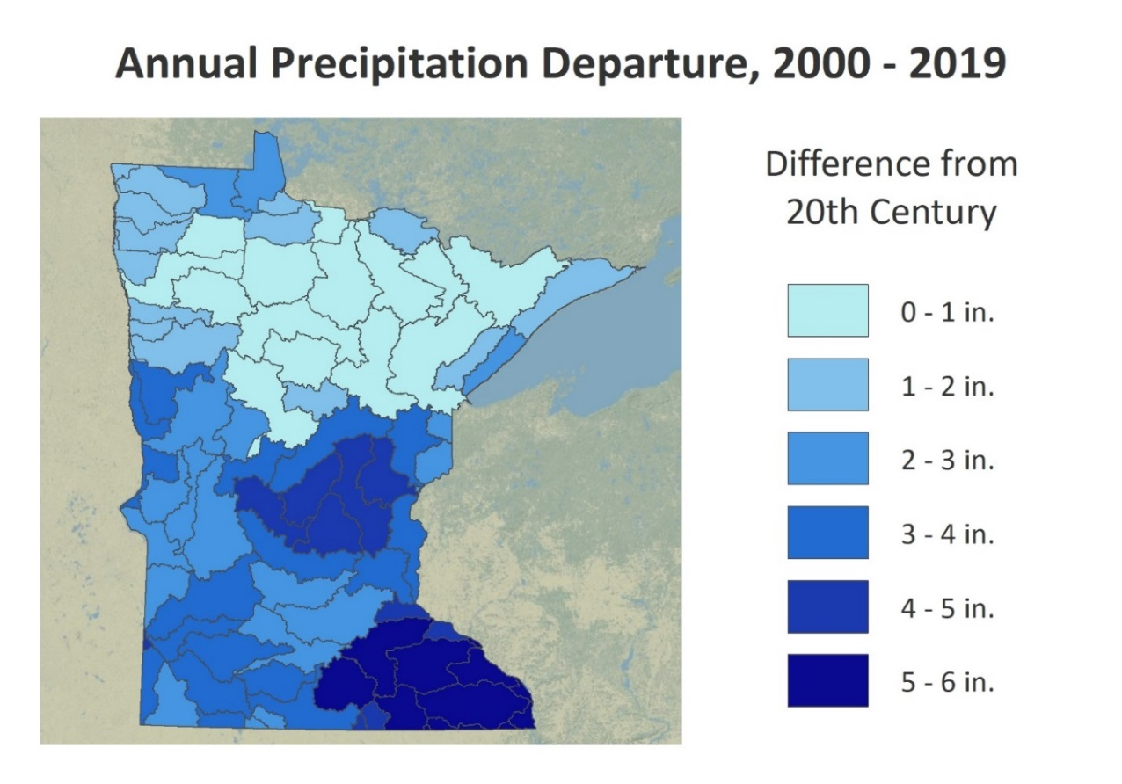
Annual precipitation increases between 20th century averages and 2000-2019 averages in watersheds throughout Minnesota Source: DNR State Climatology Office and the DNR Watershed Health Assessment Framework program
In addition, large rain events that produce six inches of rain across 1,000 or more square miles, often referred to as mega rains, have increased in frequency. There have been nearly three times as many mega rains in the last 18 years (2000-2017) than the previous 27 years (1973-1999). More information on Minnesota’s mega-rain events is available at: https://www.dnr.state.mn.us/climate/summaries_and_publications/mega_rain_events.html.

River Flows
River flow is another key external factor influencing nutrient delivery to Minnesota’s rivers and lakes. Changes in river flow are driven by changes in climate, but are also affected by altering hydrology, land uses, soil quality, and other factors. Increases in river flow can cause increased streambank and bluff erosion which constitutes the largest source of sediment in many of our high sediment rivers. Since soil phosphorus is attached to the eroded sediment, flow increases can also result in total phosphorus increases.
During the past 20 years (1999 to 2018), data collected by the Metropolitan Council Environmental Services show that annual average streamflow in the Minnesota River has increased by 68% at the Jordan monitoring site and 75% near the river’s mouth at Fort Snelling. The recent decades are part of a long-term Minnesota River flow increase that started prior to 1940 (see figure below).
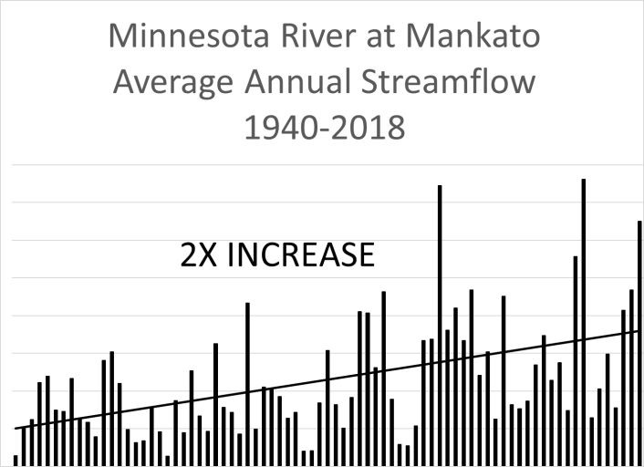
Average annual streamflow trends in the Minnesota River at Mankato (1940-2018).
The Mississippi River flows have also increased during the 1999 to 2018 timeframe. Minimum flows at Anoka increased by 64%. Average and maximum flows at Red Wing have increased by 40% and 38%, respectively. It is challenging to achieve nonpoint source nutrient load decreases during periods of such significant river flow increases.

Land-use
Changes in and wetland acreages affect how much precipitation reaches lakes, rivers, and wetlands, or percolates into aquifers. Land use also has a major influence on the quantity and quality of runoff and nutrient losses to groundwater. A summary of major land use changes in Minnesota is presented below.
Urban
Developed lands, often characterized by an increase in impervious surfaces, increased by 14.3% from 2010 to 2017. As previously discussed, increases in impervious surfaces contribute to increases in nutrient loads from surface runoff.
Cropland
Total acres of agricultural land use in Minnesota has remained relatively constant over time. However, the type of crops has changed in past decades to fewer small grains and alfalfa acres and more corn and soybeans. Between 2012 and 2018, most of the major crop acreages remained fairly stable. Soybean acreages surpassed corn in 2017 and 2018 (see figure below).
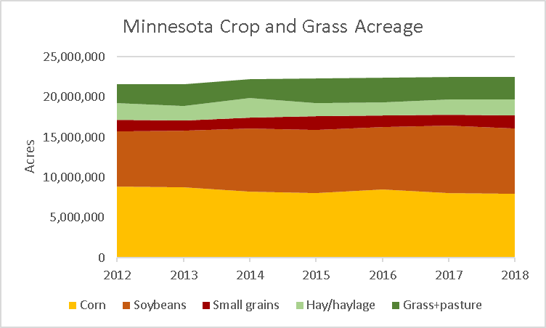
Statewide crop and grass/pasture acreage changes between 2012 and 2018 as identified from Crop Data Layer (CDL).
Wetlands
In 1991, Minnesota adopted a no-net-loss wetland policy because of the benefits associated with wetlands. Then in 2006, Minnesota initiated a rigorous, long-term monitoring program to track changes in wetland quality and quantity over time. Between 2006 and 2008, the monitoring effort assessed wetland abundance in almost 5,000 plots across Minnesota to serve as a baseline. Those same sites are reassessed every three years to track the amount of change that is occurring. Results showed a net wetland gain of 6,550 acres (0.06%) from 2009 to 2014. While historical patterns of wetland loss appear to have leveled off, more recent efforts have focused on restoring and maintaining wetland functional quality.
Irrigation and Drainage
Cropland irrigation and artificial drainage changes how water and nutrients move through the soil and into surface waters. These activities can affect the amount of nitrate and phosphorus delivered to waters.
Less than 3% of the total cropland in Minnesota is currently irrigated, using approximately 103 billion gallons of water. There has been a slight increase in irrigation in Minnesota according to the U.S. Census of Agriculture. Acres of irrigated land increased by 21% during 2007-2017 and by 17% from 2012 to 2017.
While the statewide increase in irrigated agriculture is relatively small, increases can have large impacts in local watersheds. For example, the amount of irrigated lands within the Straight River watershed, which drains to the Crow Wing River in north central Minnesota, nearly doubled between 1992 to 2016.
Grassland and forested areas with very low nitrate leaching potential were converted into irrigated row
crops with much higher potential for nitrate leaching.

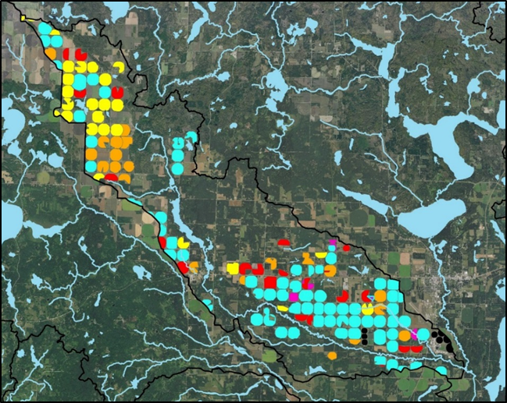
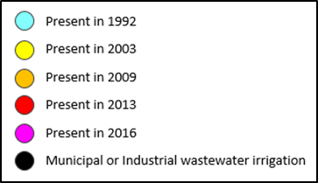
Added irrigation between 1992 and 2016 in the Straight River Watershed, and subwatershed of the Crow Wing River Watershed (Information provided by MPCA).
Subsurface tile drainage has the potential to transport nutrients out of the root zone to surface waters, especially nitrate. During the past two decades, subsurface tile drainage installation has continually increased in Minnesota. A substantial increase in the installation rate occurred when a combination of wetter climate coincided with higher corn and soybean prices, particularly following 2008.
The 2017 U.S. Census of Agriculture indicated that tile drained lands increased in Minnesota by 25% during the five-year period between 2012 and 2017 (see table below). The Census report also indicated that over eight million acres of land is tile-drained, which is approximately half of the total statewide corn and soybean lands. The Cropland Data Layer (CDL) published by USDA indicates there are about
20 million acres of cropland (i.e., corn, soybean, sugar beets, wheat, oats, potatoes, barley) in Minnesota. Therefore, the 2017 Census data indicates that tile-drained land represents approximately 40% of Minnesota’s cropland.
Minnesota Land Use Data Practices (2012 to 2017).
Practice | 2012 Acres | 2017 Acres | Increase 2012-17
Land Drained by Tile | 6,461,173 | 8,079,984 | + 1,618,811 (+25%)
Land Drained by Ditches | 4,548,977 | 4,674,449 | + 125,472 (+3%)
Source: USDA NASS US Census of Agriculture, Table 41 – Minnesota Land Use Practices

Minnesota State Demographic Center. 2019. Latest annual estimates of Minnesota and its Economic Development Region’s population and households. Release August 2019. https://mn.gov/admin/demography/data-by-topic/population-data/our-estimates/
USDA National Agricultural Statistics Services.2012 and 2017. 2012 and 2017 Census of Agriculture. State level data for Minnesota. wq-s1-84e
Blann, K. 2019. Personal communications. The Nature Conservancy, Minnesota.

