**Even if they say “flushable,”**

**disposable wipes WILL clog pipes**

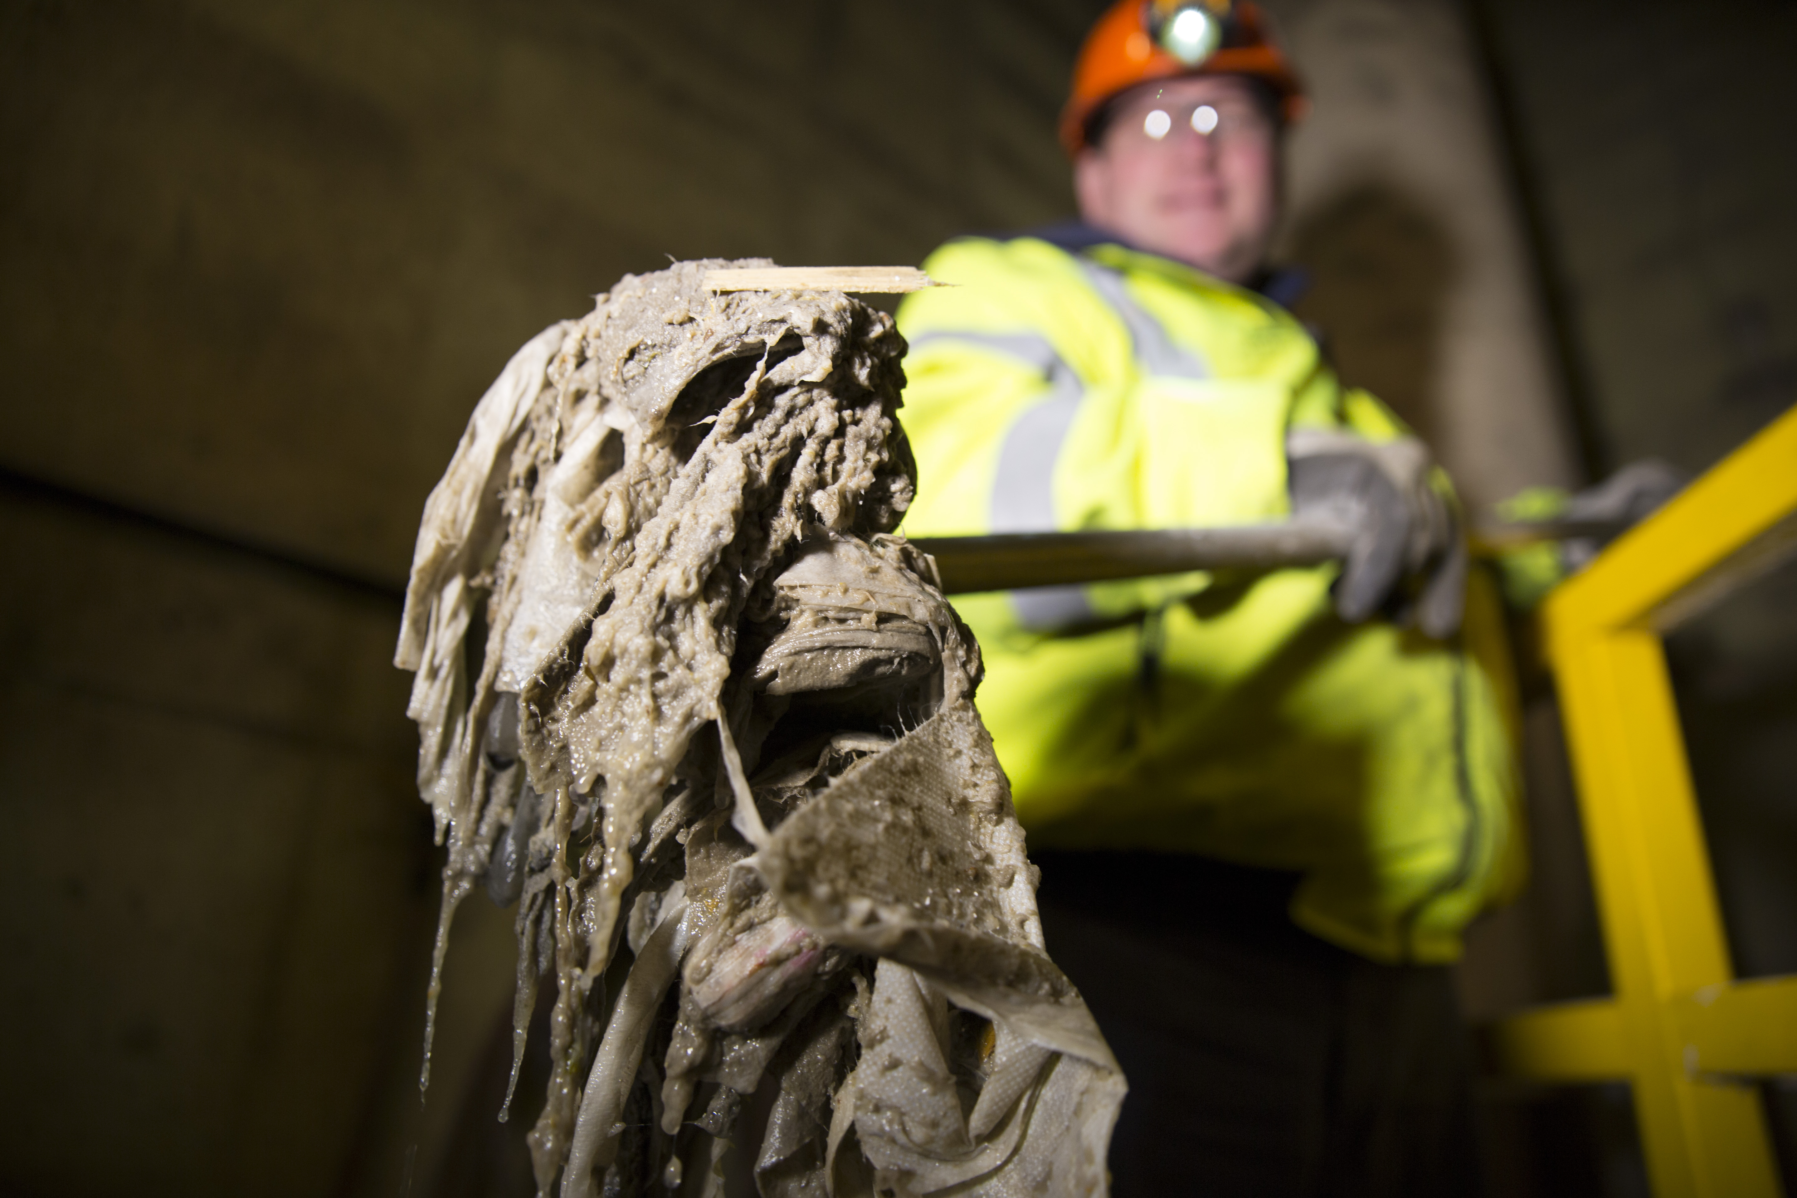

**Prevent costly backups**

**Place wipes in trash**

INSERT CITY LOGO AND WEBSITE ADDRESS