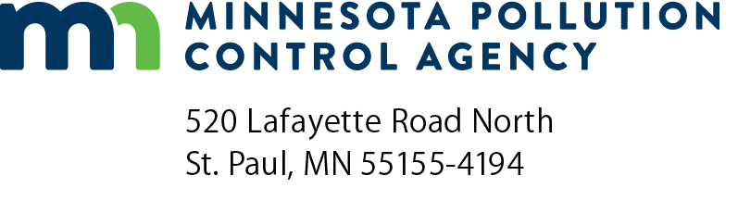 | Solid waste case specific beneficial use determination application checklist  Solid Waste Permit Program  Doc Type: Permit Application
Purpose: This checklist has been developed as a guide for permit application preparers and reviewers in order to assist with the submittal of a substantially complete permit application. Thoroughly review all applicable rules, statutes and guidance documents for further details and requirements. Minnesota Rules can be found on the Office of the Revisor of Statutes website at: https://www.revisor.mn.gov/rules/. All guidance documents can be found on the Minnesota Pollution Control Agency (MPCA) Solid waste publications webpage at: http://www.pca.state.mn.us/lupg880.
Many items listed below must be discussed in depth within the permit application submittal package. Be sure to include the most recently updated information, drawings and plans. Previously submitted documents cannot be referenced; all necessary documents must be included in this package. The permit application submittals should discuss all applicable MPCA Guidance Documents; include justification if the facility does not follow the guidance provided.
Instructions for permit application preparers: The following checklist must be completed and included with a permit application for all solid waste case specific beneficial use determination. In the table below, indicate in the far left column the name and page number(s) of the document where the specified rule requirement is addressed. If the rule requirement does not apply, please indicate with “n/a” for not applicable. The permit application will be determined to be incomplete if there are any blank spaces in this column.
Document  and  page number | Minn. R. citation | MPCA use only
 |  | Completeness review |  | Comments
 |  | Admin | Technical
7001.3300, item A
General description of the facility
7001.3300, item F
Description of procedures, structures, or equipment used
7001.3300, item N(1 to 18)
Topographic and development map
7001.3300, item P(1 to 9)
Operations and maintenance manual
7001.3300, item S
Full size copies of all engineering plan sheets
7035.2860, subp. 5(A)
Description of the solid waste, manner in which it is generated, quantity generated, quantity to be utilized, and its proposed end use
7035.2860, subp. 5(B)
Results of chemical and physical characterization of the solid waste done in accordance with part 7035.2861
7035.2860, subp. 5(C)
Evaluation of the human health and environmental impacts the proposed use may have and a comparison of these impacts with those from other management alternatives for the solid waste

Document  and  page number | Minn. R. citation | MPCA use only
 |  | Completeness review |  | Comments
 |  | Admin | Technical
7035.2860, subp.5(D)
Verification that the end product complies with industry standards and specifications for its intended use and a comparison of the chemical and physical characteristics of the solid waste proposed for use with the material it will replace
7035.2860, subp. 5(E)
Description of the routine sampling and analysis that will be conducted of the solid waste to ensure that the information submitted for review is representative and the solid waste has consistent characteristics. The description must include the procedure and frequency of sampling and analysis, parameters to be analyzed, analysis methods, and laboratory reporting limits to be used
7035.2860, subp. 5(F)
A copy of a contract to purchase or use the proposed product or other documentation proving that a market for the proposed product or use exists
7035.2860, subp. 5(G)
Detailed description of how and where the product will be distributed. This should also include a detailed description of how the solid waste will be managed from the time it is generated until the time it will be utilized and the management practices that will be in place to ensure that human health and the environment are protected
7035.2860, subp. 5(H)(1)
A complete description of the types of storage to be used prior to beneficial use
7035.2860, subp. 5(H)(2)
A description of how the solid waste will be managed to meet the requirements in part 7035.2855
7035.2860, subp. 5(I)
Description of any wastes that will need to be managed as a result of beneficially using the solid waste
7035.2860, subp. 5(J)
Verification that local units of government with authority to regulate the proposed process or use of the solid waste have received a copy of this application and have been provided information on who to contact at the agency to provide comments on the proposed beneficial use activity
7035.2860, subp. 5(K)
A proposal for notification of interested or affected parties. The agency shall review this proposal and make a determination on the appropriate notification procedures

