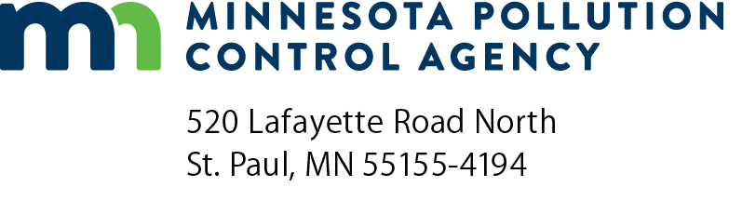 |  | Renewal application for Operator/Inspector certification  Solid Waste Program  Doc Type: Certification Application
The renewal fee of $15.00, made payable to the  Minnesota Pollution Control Agency, must accompany  the application. A $15.00 charge will be applied after the  expiration date.  Select one: Operator or Inspector  Select one: Type II or Type III  Select one: Check or Credit Card (fill out form on next page) |  |  | MPCA Use Only
 |  |  | Company name:
 |  |  | Check number:
 |  |  | Amount of check:
 |  |  | Date of check:
 |  |  | Date deposited:
Mail application to:  Secure Fax: | Attn: Landfill Operator Training – 5th floor  Minnesota Pollution Control Agency  520 Lafayette Road North  St. Paul, MN 55155-4194  Contact: 651-757-2496  651-797-1385

A. General Information
This application form must be correctly filled out and all questions must be answered in full.
Last name: |  |  |  |  |  |  |  |  |  |  | First name: |  |  |  |  |  |  |  |  | Middle initial:
Present position: |  |  |  |  |  |  |  |  |  |  |  |  | Employer:
Name of landfill (if applicable):
Home address:
Designated mailing address:
City: |  |  |  |  |  |  |  |  | State: |  |  | Zip: |  |  |  |  | County:
Email:
Present certificate number: |  |  |  |  |  |  |  |  |  |  |  | Business phone number:

B. Training and education
List all relevant short courses, in-service training, extension, individual college, courses, etc., completed during the three-year period since your certificate was issued. Give name of course, subject, location, date, and number of course hours, AND include proof of attendance i.e., attendance certificates. (Required by Minn. R. 7048.1000)
Course title | Course hours | Subject | Location | Dates

C. Certification

I hereby certify that the information contained in this application is true and correct to the best of my knowledge:
Print name: |  | Title:
Signature: |  | Date (mm/dd/yyyy):

(This page intentionally left blank.)

Credit card authorization
Solid Waste Program
Instructions: You may complete this form electronically; then print and mail BOTH PAGES with your payment, or fax this with credit card details.
Do not email it as an attachment with credit card information.
Send to: Landfill Operator Training - 5th floor
Minnesota Pollution Control Agency
520 Lafayette Road North
St. Paul, Minnesota 55155-4194
651-757- 2496
Secure fax: 651-797-1385
Tennessen Warning: Some of the information you are being asked to provide on this form (i.e., some of your credit card details) is classified by state law (Minn. Stat. § 13.37, subd. 1a) as private data. You are being asked to provide this information to assist the Minnesota Pollution Control Agency in processing your renewal application certification payment. You are not required to provide any of the requested information. If you provide the requested information, this will assist the agency in processing your payment. If you do not provide this information, the agency may be unable to process your payment. The private information that you provide will be available only to those within the agency and the State whose work assignments reasonably require access to it and to other entities/persons authorized by law or court order.
Credit card information
Visa MasterCard American Express (Amex)
Name on credit card:
Credit card number: |  |  |  |  |  |  | Expiration date (mm/yyyy): |  |  |  |  | Security code (CCV):
Address:
City: |  |  |  |  |  |  | State: |  |  |  |  |  | Zip code:
Phone number: |  |  |  |  |  |  | Email address:
Name on certification being renewed:
Signature: |  |  |  |  |  |  |  |  |  |  | Amount:
Service fees
US Bank will be charging a separate service fee of 2.15% for all credit card transactions and 1.25% for all debit card transactions after April 1, 2022. A separate non-refundable service fee will be displayed on your credit card statement, in addition to the MPCA charged renewal fee.
I accept the credit card service charge.

