|  |  |
| --- | --- |
|  | **SOP 4.26 Batteries**  Information for HHW Programs |

Rechargeable Lithium Battery (RLB) Management

This Standard Operating Procedure provides proper packaging procedures to correctly process lithium batteries received at this Household Hazardous Waste (HHW) Facility. Lithium batteries are responsible for fires in solid waste facilities, HHW collection vehicles, drop-off programs and other disposal facilities.

RLB Processing

Ensure safety is a priority when accepting RLBs as incoming quantities continue to increase.

* Note there is an imminent need for physical separation within some battery types due to the potential for thermal runaway (a process which may produce flames on individual battery cells).
* Sort RLBs in a location that ensures a clear exit route, and that the sorting area is at least 15’ away from flammables or high heat sources. *Disclaimer: There are no recommendations on a “safe” distance to store RLBs from flammables; the goal is minimizing potential hazards or risks.*
* RLB failures resulting in fire are typically a result of manufacturer defects, vibrations, or electrical shorts. Contact the fire department to manage any hot RLB as it may be only a manner of minutes before a thermal runaway turns to fire. If RLBs are exhibiting signs of rapidly heating up or if flames are visible, **immediately evaluate the situation.** If the fire is determined to be too large or beyond response capabilities of HHW staff [evacuate the facility and call 911]. If the situation is determined to be manageable by HHW staff, avoid breathing fumes, remove any source of combustible materials, and extinguish the fire using a suppression blanket designed for lithium battery fires. If necessary, utilize fire extinguishers for batteries that are ABC or B rated for Lithium-ion rechargeable battery fires and Class D fire extinguishers for Lithium primary or metal battery fires.

RLB Sorting

* The [Facility Manager] is responsible for ensuring proper training for staff processing batteries. Training shall include identification of battery chemistries, how to identify damaged or defective batteries, and how to properly package and label (based on battery chemistries). Training shall also include a review of the Hazard Categorization manual provided by the hazardous waste contractor or battery recycler, and review of pertinent Hazardous Waste regulations.
* Don proper PPE, including gloves while processing RLBs.
* While sorting, check for RLB temperature; if warm to the touch, immediately move the item to an outside location and completely cover with sand and/or immediately place defective or damaged batteries, and any spill residue in a [Damaged, Defective or Recalled](https://www.call2recycle.org/safesolutions/) (DDR) RLB kit, which allows up to 4 pounds (11 pounds if shipping a single battery) of damaged batteries per 5-gallon container or 131 pounds per 55-gallon kit.
* Sort batteries based on chemical constituents and DO NOT disassemble embedded battery devices or packs; see Attachment A.
* Clearly label the battery chemistry type on each container or [Call2Recycle](https://www.call2recycle.org/) (C2R) box and do not remove the flame-retardant liner affixed inside.
* Place clear duct or non-conductive electrical tape on the positive (+) and negative (-) battery terminals, making sure not to cover the brand name or battery chemistry.
* Place only one battery or cellphone unit in each plastic Ziploc® or produce bag.
* For devices with push buttons, utilize a “tackle box” type storage; place any device with an igniter button in a separate compartment to prevent ignition. Shipping containers filled with [CellBlockEX](https://cellblockfcs.com/cellblockex/), also provide a DOT authorized safe packaging method for shipping non-taped batteries.
* Label lithium-ion battery containers with the words, ‘*Lithium-Ion Batteries for recycling UN 3480’* and label DDR battery containers with the words, *‘Damaged/Defective Lithium-Ion Battery UN3480, Forbidden for transport aboard aircraft – Ground and vessel shipment only’.* Veolia (the state contracted HW disposal company) also provides guidance with packaging container specifications, waste stream identification, and segregation.
* Maintain a routine and establish a staff schedule for sorting and taping incoming batteries and ensure all RLB storage containers are closed [by the end of each working day].

RLB Storage

**Keep RLBs dry and away from heat sources.** Exposure to water may short circuit RLBs and cause them to heat up very quickly, potentially causing thermal runaway. Closely monitor RLB collection containers as terminals allowed to come in contact with each other or with other metals have the potential to ignite (see C2R [Minimum Terminal Protection Requirements](https://www.call2recycle.org/download/18685/)) and document container routine inspections [weekly]; see Attachment B. Take preventative steps to protect battery containers from damage, including storing:

* In a location away from public drop off areas.
* In facility areas with impermeable flooring.
* In a fireproof room or outside building and isolated away from flammables, oxidizers or explosive HW materials.
* Out of direct sunlight in a dry, well ventilated, and cool location (between 40 and 80 degrees).
* In a location that will prevent jolting (away from forklift traffic areas).
* Stacked in containers no more than four high; ensure no heavy objects are stacked on top.

RLB Shipping

* Ship batteries in compliance with [U.S. DOT safety regulations](https://www.phmsa.dot.gov/lithiumbatteries) (typically at 66 pounds) or within one year of the first date of collection.
* Use caution when [transporting batteries](https://www.phmsa.dot.gov/lithiumbatteries) back to your facility from a HHW collection event [consider the option of not collecting waste batteries at an HHW event]. Ensure RLB containers are secured and stored on the transport vehicle away from flammables, oxidizers, reactive or explosives.
  + - * Do not ship DDRs with undamaged batteries (4.4 pounds per DDR box set via special DOT permit).
      * Properly package other non-disassemble-type devices with embedded batteries.
* Read and follow the instructions on all C2R boxes; contact C2R (877-723-1297) for any packaging questions. Automatic free box replenishment may be available through C2R. If you need free boxes for small or [damaged batteries](https://www.fmcsa.dot.gov/newsroom/fmcsa-issues-safety-advisory-related-transportation-recently-recalled-samsung-galaxy-note7)-remind C2R you are a MN HHW Program.
  + - * You may request pallet quantities of Call2Recycle shipping boxes as they often contain extra cell block liners. If your facility doesn’t tape the lithium-based batteries immediately upon arrival or by the end of each workday, an alternative would be to purchase heavy gauge 5-gallon metal pails and line them with the extra cell block material to make them fire resistant and prevent a runaway reaction. Store filled containers in an area of our facility devoid of combustibles and store filled containers at least 3 feet apart.

**Attachment A – Battery Types**

Once a battery is no longer useful, the type and chemistry will help determine which of the various management options to use to prevent commingling of incompatible wastes. C2R does not accept wet batteries, but will accept batteries that weigh less than 11 pounds, including:

• Rechargeable batteries

• Nickel Cadmium (Ni-Cd)

* Nickel Metal Hydride (Ni-MH)

• Small Sealed Lead Acid (SSLA/Pb)

• Nickel Zinc (Ni-Zn)

• Lithium Ion (Li-Ion)

• Lithium primary (single use lithium)

• Single-use or alkaline

• AA, AAA, 9V, C, D, and button cells

• Cellphones (with or without batteries)

**Rechargeable, Nickel Cadmium or Metal Hydride Batteries**

* Rechargeable Ni-Cd or Ni-MH battery types less than nine volts do not require thermal protection.
* Often found in cordless power tools, cell phones, cameras, radios, or bio-medical equipment and look like common single use AA, AAA or alkaline batteries.
* Larger Ni-Cd/Ni-MH batteries over 9 volts typically found in power tools.

**Small Sealed Lead Acid Batteries**

* SSLA/Pb do require thermal protection if over nine volts and are commonly found in scooters, toys, fire protection devices, hospital equipment or emergency lighting.
* May be removable or permanently attached to a device.

**Nickel Zinc Batteries**

* Alkaline and carbon Zinc battery types less than nine volts do not require thermal protection and may be placed in the trash.
* These batteries can generally be removed when they stop powering the device.
* Ni-Zn battery types are commonly found in cameras, wireless keyboards, small electronics, alarm clocks, calculators, flashlights, remote controls, radios, and toys.

**High Energy Lithium Batteries**

* High energy (>300WH) lithium batteries must be stored and shipped one battery per 55-gallon metal drum (with vermiculite) and one drum per pallet.
* Store and process as far away as possible from flammables or heat sources, if possible, store in an outside building that complies with DDR battery fire codes.
* It is the HHW County Program decision whether to accept high energy batteries; refer to State hazardous waste contractor for questions on packing or shipping high energy batteries to ensure DOT compliance.

**Lithium Batteries**

* Some consider the gases emitted from lithium batteries to be more dangerous than fires;

see Attachment B.

* Non-rechargeable lithium batteries cannot be placed in C2R shipping boxes. Currently, the MN State Battery Statute does not provide coverage for these types of batteries. Primary lithium batteries are shipped through the HW contract and there is pricing for them. Packing this battery type is covered in the MN Veolia Hazardous Categorization Training Manual.
* The degree of thermal runaway/heat a cell-battery can generate is directly related to remaining charge.
* Li-Ion battery types require terminal protection as the quantity of lithium chemistry batteries used in household products has increased while the protective casings have become thinner to make products lighter, which increases the risk of fire.
* Lithium-ion batteries contain two thin plates separated by a sponge saturated with a combustible liquid; if the plates come in contact with one another, the liquid will likely heat up causing combustion.
* These batteries have a quicker charge time along with a high energy density and can hold a charge longer.
* Use extreme measures to not drop, puncture or damage Li-Ion or lithium primary batteries and check each individual battery to verify integrity as damaged, defective, or recalled batteries pose a fire hazard.
* Isolate Lithium metal battery containers from other types of batteries.
* ‘Coin” batteries are thin, round and contain silver, cadmium, mercury, lithium, or other heavy metals.
* Some instances allow for button or ‘coin’ batteries to be placed in the trash as they are primary batteries and have zero charge remaining when dead. If shipping, use bubble wrap to prevent contact.
* Non-rechargeable lithium cells/primary cells are generally individual cells (vs. batteries) and includes coins, buttons, and sizes like AAA, AA, C, 9 volt and D.
* Non-rechargeable lithium battery types are commonly found in cameras, watches, remote controls hand-held games, smoke detectors, cellphones, power tools, cameras, laptops, toys, e-cigarettes appliances, tablet, or e-readers.

**Lithium “Small” Rechargeable Batteries**

* Sort and tape all lithium batteries ASAP and store non-damaged batteries and cells (<300 Wh) into the standard C2R collection boxes lined with [Cellblock](https://www.call2recycle.org/product/cellsafe-ddr-li-ion-battery-recycling-kit/) (which will contain fires).
* Store damaged <300 Wh batteries in DDR boxes provided free from C2R (also lined with fire containment material). Do not store over six pounds in each container and do not overfill. Also, may be placed with other RLB, if taped. Undamaged <300Wh lithium (not lithium-ion) batteries may be shipped with Veolia if taped and using a five-gallon poly pack (current disposal price is $5.79/lb).
* Pack damaged lithium-based batteries >300Wh with vermiculite in a 30 gallon “vented” poly pack. The vented part includes a special bung that has a punch out center, so if a reaction took place the center would pop out and allow the pressure to escape.
* Call C2R to obtain a >300Wh kit for any undamaged batteries (current price is $85.50 and allows for up to 26.4 pounds of batteries or $3.24/lb.).
* There are also several services which offer prepaid shipping containers that are mailed to homeowners to place the <300 Wh batteries into and then ship to a recycler. Batteries Plus is an option for communities that have this retailer, as they will accept almost everything, except the >300 Wh.

**Electronic Cigarettes or Vaping Devices**

* Vaping devices often use the drop-in 18650-battery types (slightly larger than AA batteries); see Attachment B.
* The hallmark of the e-cigarette devices is that the 18650 batteries need to be removed and charged.
* Unlike the 18650 batteries, ‘Juul’ (an electronic cigarette company) devices resemble small computer flash drives and do not appear to carry the explosion risk. The Juul batteries are lithium-ion but have overcharge protection and are designed to remain permanently in place.
* 18650 batteries are also used in certain types of electronic cigarettes called mechanical mods, which are specialized vaping devices that do not have an internal safety circuitry; see Attachment B.
* C2R will accept electronic cigarettes if the cartridge has been removed (does not apply to one-time use/disposable).

**Embedded Rechargeable Batteries**

A box containing many vape pens may start a thermal process and fire if even a single vape pen’s button is pushed in. Prevent the pen buttons from being engaged by using cardboard dividers in the shipping box. Many vape pens don’t have ignitor buttons; it is fine to tape or bag like any other battery or device. The only way to really tell what type of battery is inside to take the device apart as the battery is embedded within the casing (see Attachment B). If the vape pen is not rechargeable, it can safely be placed in the trash as it has a single use alkaline battery [customize if you do something different]. If the vape device requires disassembly to remove the battery, take actions that will prevent damage to the battery, including:

* Set up disassembly area on a non-combustible surface, away from flammables or combustible materials.
* If the vape device has a button or switch, turn it to the ‘off’ position; five pushes of the button turn the battery on or off (this is a 3-step process); see Attachment B.
* Use caution to not use excessive force during the disassembly process and use appropriate tools that will assist in the battery removal process.
* Once the vape battery is removed, bag or tape battery terminals and place in C2R box.
* Place non-removable pens with their intact batteries in the Call2Recycle DDR kit.
* Dispose of vape pen non-disassembled with cartridge/pod/full tank via direct incineration (use 5-gallon containers and vermiculite to hold approximately 15 pounds/50 devices).
* To dispose of vape pen non-disassembled NO cartridges: ship for disassembly (price is the same as shipping lithium batteries) as recycling may not be an option at this point.

**Spent Lead Acid Batteries**

* Spent lead acid batteries (SLABs) contain lead and corrosive acid.
* Bring automotive SLABs to a retailer for recycling.
* SLABs are often found in vehicles, backup power equipment, sump-pumps, uninterruptable power supplies, computer, or critical equipment.

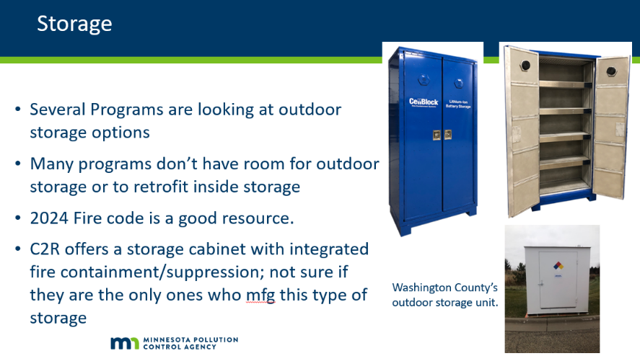

**Attachment B – Battery Storage, Fire Risks and Safe Handling**

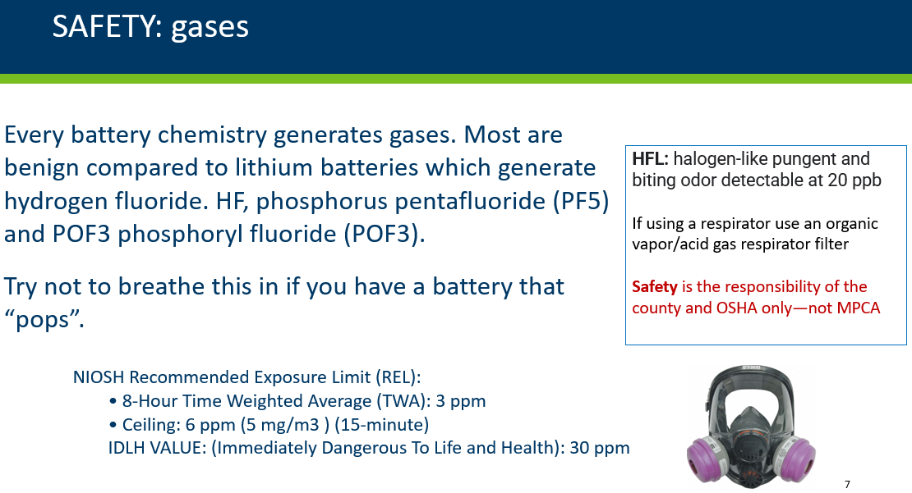

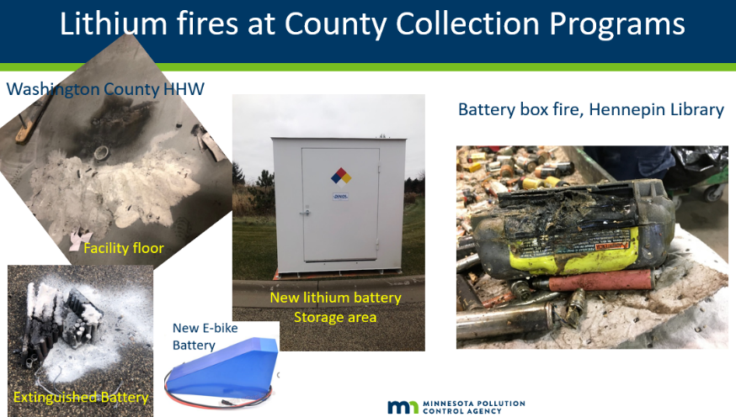

Class D fire extinguishers are not required since there is so little lithium inside these batteries. The battery must be cooled down from about 3,000 F; using sand to smother a fire may work, but copious amounts are needed. Don heat resistant gloves and use tongs to remove any hot item and smother the flame with a lithium fire suppression blanket and/or smothering pads (often used when working with smaller batteries). Utilize the C2R CellBlock, which is a puffed glass that melts, encases and extinguishes the heat and fire.

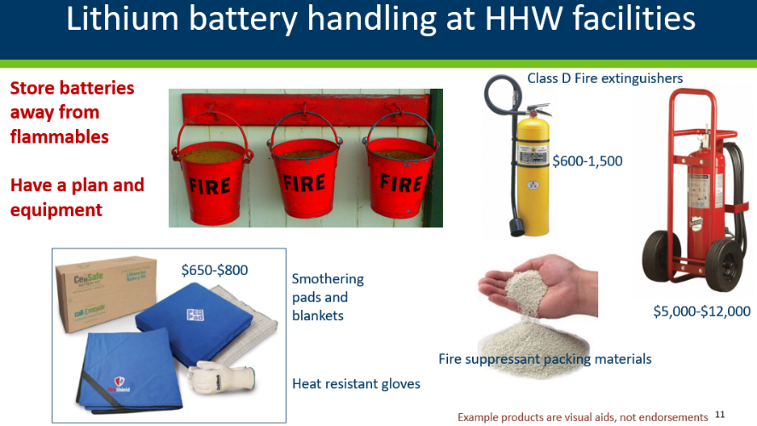



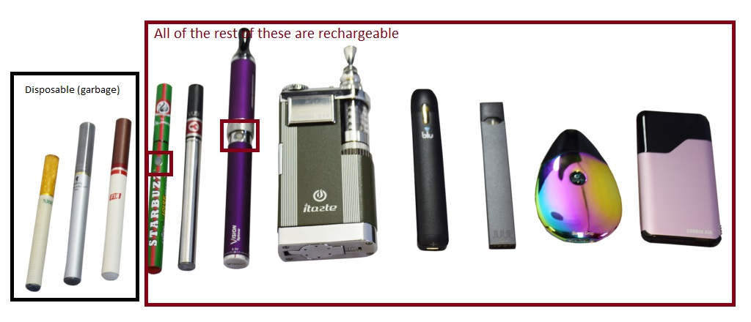

The pictures above provide general guidance highlighting the difficulty in distinguishing between rechargeable and non-rechargeable battery types. The picture below shows typical batteries found in electronic cigarettes.

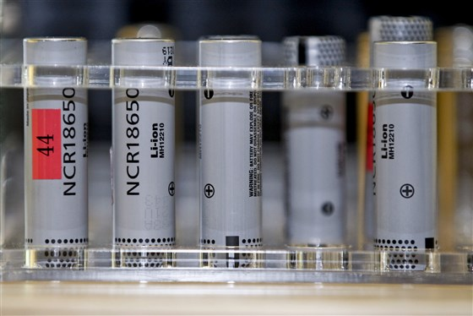

Additional resources

* To review the complete list of batteries that must be protected to comply with DOT shipping requirements see C2R training materials and guidance: <https://www.call2recycle.org/safety/> or contact Customer Service at 877-723-1297
* Universal Waste factsheet: <https://www.pca.state.mn.us/sites/default/files/w-hw4-62.pdf>
* Rechargeable Battery factsheet: <https://www.pca.state.mn.us/quick-links/rechargeable-batteries>
* Vaping Liquids and E-cigarettes Wastes factsheet: <https://www.pca.state.mn.us/sites/default/files/w-hw4-65.pdf>
* [DOT Mailing Batteries Guidance Document](https://www.phmsa.dot.gov/safe-travel/batteries)
* [United Postal Service - Standard Operating Procedure: Recycling Rechargeable Lithium-Ion Batteries](https://about.usps.com/postal-bulletin/2012/pb22345/html/info_014.htm)
* [PRBA National & International Battery Fire Codes](https://codes.iccsafe.org/content/IFC2024P1/chapter-3-general-requirements#IFC2024P1_Pt02_Ch03_Sec320)