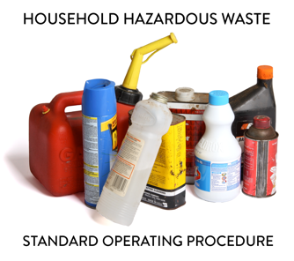 | SOP 4.25: Non-Industrial Declaration

1. Introduction
Household Hazardous Waste (HHW) Programs may accept Product Reuse Materials (PRM) from a non-profit, retail entity, government, or other institution (Donator) and are not required to be licensed as a Very Small Quantity Generator Collection site to do so. Acceptance of PRM is allowed in the MPCA State/County contract agreement. The HHW Program designated staff responsible for proper PRM management and compliance is the [Program Manager].

2. Accepting Non-Industrial Products
Non-Industrial products are often packaged for sale to households. These materials are not designed for use by manufacturers, are often no longer needed, have been discontinued or cannot be used for their intended purpose. It is not recommended that products designed for industrial use be placed on product reuse shelves. Accepting PRM from businesses classified as a Small or Large Quantity hazardous waste generators is not recommended.

2.1 The Program designated staff shall be properly trained to evaluate incoming PRM offered by the Donator to ensure the items are appropriate to place in this facility for re-use. The items must:
- Be itemized on a product list, along with amounts.
- Be stored in original containers and with original labeling.
- Be intended for use by households and likely to be taken and reused.
- Have contents that are still effective if used for their intended purpose.
- Be safe based on their relative hazards.
- Not be treated or disassembled.
2.2 Doner participants must attest to or sign a “Non-Industrial Declaration” (see Attachment A) stating that the products are intended for household use. [This Program has verified with the local County Solid Waste Office the protocol of using a declaration in lieu of a variance and will revise this SOP to reflect that confirmation]. PRMs will not be accepted without advance review and approval. The Program designated staff person shall:
- Ensure the Donator understands this Program will only accept the agreed upon PRMs and the items will be accepted initially without a management or disposal fee.
- Return products to Donator if not taken by for reuse within 60 days of acceptance.
- Discuss proper transport requirements, including ensuring incoming containers are not leaking, are tightly closed, have intact original product labeling, and include sufficient absorbents to contain potential spills.
- Ensure a shipping paper is not required prior to transport (See Section 6 of link as PRM are not considered a waste);
Provide a disposal receipt (advise the Donator to keep documentation for at least 3 years).

Attachment A

Acceptance of Household Products
Non-Industrial Declaration

Name of Business and/or Donator: ___________________________________________________________
Contact Person: __________________________________________________________________________________
Address: _______________________________________________________________________________________
Phone: _________________________________________Vehicle License Plate Number: _______________________
Name of Person Transporting Material, if not listed above: ________________________________________________

I hereby declare under penalty of perjury that the material listed on this form or attached inventory sheet is not waste, is not an industrial product, and is usable for its intended purpose as a household product.

[I further understand that if the material brought in is not taken for reuse within 60 days, the HHW Program Manager may invoice me for the cost of disposal of listed material.]

SIGNATURE: ______________________________________________________________ DATE: _______________

Product Inventory

Material Type/Product Name | Size of Containers | Number of  Containers

