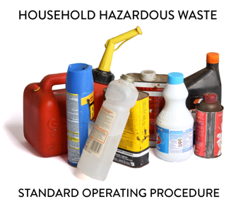 | SOP 4.24 PCB Wastes  General Guidance for HHW Programs
Note: This guidance document is for informational purposes only and outlines basic employer requirements. The MPCA makes no guarantee that this document satisfies the requirements of its users ensuring compliance. It is the sole responsibility of your specific HHW Program employer(s) to determine if OSHA, DOT and RCRA requirements have been met.

1. Introduction
This Household Hazardous Waste (HHW) program accepts many types of hazardous materials; this Standard Operating Procedure provides guidance to ensure proper acceptance, processing and shipment requirements are followed for safe and efficient acceptance of polychlorinated biphenyls (PCBs) waste types.

2. Training requirements
2.1 Determine designated staff. The dedicated Program staff to ensure compliance and proper household hazardous waste (HHW) processing is the [Facility Manager]. This person shall ensure facility staff successfully completes all required training.
2.2 Include site-specific information. Training shall be specific to program needs and job expectations.
2.3 Safety requirements. Ensure PPE use for staff processing HHW to minimally include nitrile gloves, Tyvek or chemically resistant apron, sleeves and eye protection.

3. Processing PCBs
- Fluorescent light bulbs are frequently accompanied by ballasts, which serve as electrical insulators and often contain PCBs, a hazardous waste. PCBs can also be found in motor start capacitors used in household appliances and industrial equipment.
- Unless explicitly labeled with the phrase “No PCBs,” all ballasts must be assumed to contain PCBs. Non-PCB ballasts may be either recycled or disposed of with regular solid waste, in accordance with applicable regulations.
- A hazardous waste manifest is required for the transport of PCB ballasts, as they are presumed to contain PCBs in concentrations exceeding 50 parts per million (ppm). A shipping paper is not an acceptable substitute for a manifest when transporting PCB waste.
- PCB-containing ballasts—both leaking and non-leaking—must be stored in separate, properly labeled containers. Each container must include adequate absorbent material to contain any potential leaks and must be kept securely sealed. The standard container used is a 55-gallon drum should be filled no more than ¾ of its capacity and must not exceed a total weight of 800 pounds.

