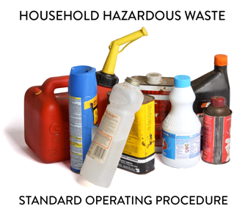 | SOP 4.19 Radioactive Wastes  General Guidance for HHW Programs
Note: This guidance document is for informational purposes only and outlines basic employer requirements. The MPCA makes no guarantee that this document satisfies the requirements of its users ensuring compliance. It is the sole responsibility of your specific HHW Program employer(s) to determine if OSHA, DOT and RCRA requirements have been met.

1. Introduction
This Household Hazardous Waste (HHW) program accepts many types of hazardous materials; this Standard Operating Procedure provides guidance to ensure proper acceptance, processing and shipment requirements are followed for safe and efficient acceptance of friable asbestos.

2. Training requirements
2.1 Determine designated staff. The dedicated Program staff to ensure compliance and proper household hazardous waste (HHW) processing is the [Facility Manager]. This person shall ensure facility staff successfully completes all required training.
2.2 Include site-specific information. Training shall be specific to program needs and job expectations and be presented in a manner staff comprehends (e.g., language barriers).
2.3 Safety requirements. Ensure PPE use for staff processing HHW to minimally include nitrile gloves, Tyvek or chemically resistant apron and sleeves and eye protection.

3. Processing Radioactives
- Radioactive waste may include items generated from radioactive sources (e.g., gas chromatographs, well logging, moisture density devices, smoke detectors, thorium mantles, lock illuminators, old chemistry sets).
- This Program does not accept radioactive materials under normal circumstances but may choose to manage those waste types on an emergency basis to ensure proper management and removal from public access. This Program is better able to safely manage unwanted and unusable radioactive materials than the public is.
- Avoid handling the material and do not disturb the container until preliminary evaluation is completed. Treat suspect material as if it is radioactive and limit the number of staff near immediate area of suspected radioactive materials. Only specially trained personnel shall handle radioactive materials. A Geiger counter is the primary method used to detect levels of radioactivity being emitted; equipment varies based on specific radioactive levels and types being measured. Maintain detection equipment according to manufacturer specifications.
- If radioactive materials are inadvertently received, immediately contact the State Contracted Hazardous Waste Disposal Contractor for further direction. They may instruct Facility staff to contact the MN Duty Officer, the Nuclear Regulatory Commission, or your local hazmat team.

