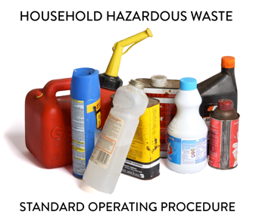 | SOP 4.07 Aerosol Wastes  General Guidance for HHW Programs
Note: This guidance document is for informational purposes only and outlines basic employer requirements. The MPCA makes no guarantee that this document satisfies the requirements of its users ensuring compliance. It is the sole responsibility of Household Hazardous Waste (HHW) Program employer(s) to determine if OSHA, DOT and RCRA requirements have been met.

1. Introduction
This HHW Standard Operating Procedure provides guidance to ensure proper requirements are followed for safe and efficient processing of aerosol and cylinder containers.

2. Training requirements
2.1 Determine designated staff. The dedicated Program staff to ensure compliance and proper HHW processing is the [Facility Manager]. This person shall ensure facility staff successfully completes all required training.
2.2 Include site-specific information. Training shall be specific to program needs and job expectations and be presented in a manner staff comprehends (e.g., language barriers).
2.3 Safety requirements. Ensure PPE use for staff processing HHW to minimally include nitrile gloves, Tyvek or chemically resistant apron and sleeves and eye protection.

3. Processing Aerosols
- Aerosol Container Overview:
Aerosol cans are pressurized containers that dispense product using liquid or gas propellants. These containers may present safety risks due to internal pressure and hazardous or flammable contents. Inhalation of propellants can also pose health hazards.
- Prohibition on Puncturing and Bulking:
Puncturing aerosol cans and bulking their contents is prohibited at all HHW Facilities. This restriction is due to safety concerns and federal regulations that prohibit the release of aerosol propellants into the atmosphere. Charcoal and activated carbon filters attached to many commercial puncturing devices do not effectively capture HW propellants to protect facility staff or the environment.
- Product Reuse Area:
Intact and usable aerosol products may be placed in the facility's product reuse area.
- Sorting Requirements:
Aerosol containers may not be comingled with cylinders; see Attachment A for additional information regarding cylinder purging. Aerosol cans must be sorted based on whether they are empty or non-empty:
- Empty cans may be disposed of as solid waste. A container is considered empty when:
  - No pressure is released through an open, functioning valve.
  - No liquid or gas is emitted when dispense nozzle is rotated in any direction.
  - Less than 3% of the original product remains.
  - No liquid is felt or heard when shaken; manage nonempty containers as a hazardous waste.
- Preparation for Shipment:
  - Remove the spray nozzle (dispenser stem) or ensure a protective cap is on all non-empty aerosol containers prior to shipment.
  - Separate cans by waste type as outlined in the Hazardous Categorization Manual (e.g., paint, pesticide, foam) and using DOT approved 55-gallon metal or poly drums or Gaylord box containers.
- Container Requirements:
- Pack into appropriate shipping containers: either DOT-approved 55-gallon drums (UN1A2 metal or UN1H2 poly) or Cubic yard (Gaylord) boxes.
- No packing material or inventory lists inside the containers; ensure weight limits are ≤1,100 lbs. for Gaylord boxes or ≤880 lbs. if 55-gallon drums.
  - Label containers with: “Waste Aerosols/Gas Cylinders,” “Used Aerosols/Gas Cylinders,” or “Universal Waste Aerosols/Gas Cylinders” (as applicable).

Attachment A: Cylinder Purging

Cylinder purging [[Delete this section if this HHW Program does not purge cylinders]]
The only types of cylinders that may be purged are empty propane or cylinders containing only oxygen, nitrogen or helium. Never evacuate or puncture cylinders with the following contents:

- Chlorine compounds
- Hydrogen bromide
- Hydrogen chloride
- Hydrogen fluoride
- Oxygen mixtures > 25%
- Pesticides
- Carbon dioxide
- Freons and foamers
- Fire suppressants
- Toxic gasses (phosgene)
- PIH gasses
- Cylinders classified as asphyxiates
- Unknowns
- Dioxins (pesticides and wood preservatives, such as: pentachlorophenol, silvex, 2,4,5-TP, Woodlife, hexachlorophene, Ronnel, 2,4,5-T, trichlorophenol and fenchlorophos)
- Gas grill cylinder types (DOT4BA240, SOT4BA350)

If removing valves or purge plugs from empty cylinder containers, staff shall:
- Not use any type of flame torch to cut cylinder as contents may be flammable.
- Ensure each cylinder is completely empty prior to removing the valve. Removal of the purge plug is the preferred method since valve use may result in freeze up.
- Ensure the cylinder outlet is directed away from face.
- Use a screwdriver, purging attachments, and valve/stem remover to remove the purge plug and completely purge contents (use the main valve if cylinder’s valve style does not have a purge plug).
- Remove the retrofitted plug (applies to old style cylinder types) and/or remove the main valve; see Photo 1.
- For one-pound cylinder types, remove nipple valve on top side of cylinder using a stem remover tool; see Photo 2.
- To purge old-style cylinder types; remove purge plug and turn main valve.
- Protect the main cylinder valve by securely attaching the valve cap (if applicable), boxing or crating.
- Empty cylinders may be recycled; residuals remaining in the cylinders may be subject to federal and state regulations.

Photo 1
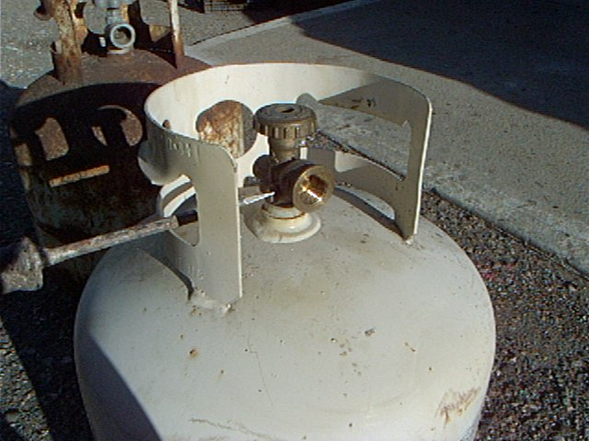
Photo 2
