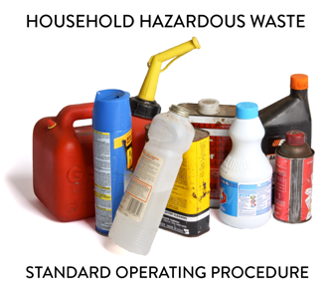 | SOP 3.01 Notification of Program Changes Information for HHW Programs
Note: This guidance document is for informational purposes only and outlines basic employer requirements. The MPCA does not guarantee that this document satisfies all applicable compliance requirements. It is the sole responsibility of county-specific Household Hazardous Waste (HHW) Program employer to determine if required standards have been met.

1. Regulatory and Contractual Requirements
Any changes to the management or operation of this HHW Program must be reported to the State. [______________________] is the designated Facility representative responsible for notifying the State of all program changes. Notification requirements for program changes are established in both the HHW program and State agency contract and in Minnesota Rules.

2. Changes Requiring Prior Notification to the State
In addition to the management or operational change notifications, the designated Facility representative must notify the State prior to implementing any of the following changes:
- Initiation of a new HHW management program.
- Acceptance of any new waste type, including:
  - Radioactive wastes (excluding smoke detectors and uranium salts)
  - Sharps
  - Ammunition, explosives, or shock-sensitive materials
  - Pharmaceuticals (controlled substances)
- On-site treatment of hazardous waste (HW).
- Identification of a responsible party for unauthorized, business, or abandoned waste (for HHW programs in Greater Minnesota).
- Any incident requiring notification of the Minnesota Duty Officer.

3. Notification to the State of Program Activities
The Program must notify the State’s Authorized Representative within 30 days of any changes, including:
- Name, address, and telephone number of the designated Facility representative.
- Location of each HHW facility.
- Facility duration and operating hours.
- Program service area.
- Methods for collecting, storing, treating, transporting, and managing waste.
- Duration of waste storage at each collection site.
- Physical structures used for waste collection and storage.
- List of additional hazardous wastes accepted by the program.
- Description of personnel training programs.
- Established safety and emergency procedures.
- HW Identification (ID) number used for manifesting waste shipments.
- Name and address of all waste transporters and facilities involved in waste management

4. Notification Requirements for Temporary and Event Collection Activities
For all temporary or event-based HHW collection activities, notification must be submitted to the State at least 30 days prior to the event, including:
- Event coordinator and contact information.
- Contractor information (if applicable).
- Street address/location of the event.
- HW ID number (if waste will be shipped from the event site via a licensed transporter).
- Service area for the event.
- Event date(s) and duration.
- Amount of time waste will be stored on-site.
- Safety and emergency procedures.
- Event date and location also must be provided to PaintCare.

