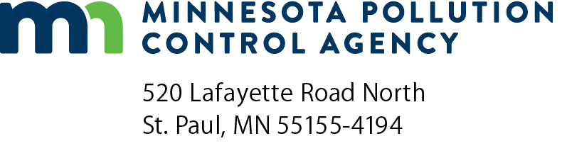 | UST supervisor certification initial/  upgrade/renewal application  Underground Storage Tank (UST) Program  Doc Type: Compliance Certification
Instructions: Return completed form and payment to the Attention: Fiscal Services – 6th floor at the Minnesota Pollution Control Agency (MPCA) address listed above. If you have any questions regarding this form, please contact Jeff Brandon at 218-302-6610 or toll free at 800-657-3864, or via email at jeffery.brandon@state.mn.us.

I. Applicant information (Please print or complete electronically)
 | Personal information
 | Name: |  |  |  |  |  |  |  | Title:
 | Home address*:
 | City: |  |  |  |  |  |  | State: |  |  |  |  | Zip:
 | Company information
 | Employer name:
 | Email address:
 | Mailing address:
 | City: |  |  |  |  |  |  | State: |  |  |  |  | Zip:
 | Telephone: |  |  |  |  |  | Minnesota UST Contractor Certification number:
Have you applied for USTs Supervisor Certification with the MPCA before? Yes No
If yes and you were certified, what is your Minnesota UST Supervisor Certification number:
Disciplines: Install Repair Closure
If yes, and you were not certified, what was deficient?

II. Type(s) of certification requested
Installation: Work involved in placing a UST in position and preparing it to be placed in service.
Repair: Work involved as the correction, restoration or upgrading of a tank system or related equipment
(e.g., repairing a hole in a tank or relining a tank).
Closure: Permanently taking a UST out of service by closing it in place, removing it from the ground, or converting it to store a nonregulated substance.

III. Work history
A. | Do you have at least two years of tank service experience? Yes No
 | If yes, briefly describe this experience:
B. | Has your certification, license or other authorization to perform tank services ever been revoked or suspended or are/were enforcement actions related to tank services pending against you in any jurisdiction? Yes No
 | If yes, briefly explain (use a separate sheet, if needed):

IV. Recertification
A. | During the four (4) year period immediately prior to making this application, have you actively participated in the field on a minimum of five (5) regulated UST projects with at least four (4) of these projects being in the discipline for which you are applying for certification? Yes No

V. Project experience (To fulfill the project-experience requirement)
• Projects must be on regulated tanks.
• Field experience must have taken place within the last four years.
• All projects must have been supervised by an MPCA-certified UST supervisor.
• Four projects (minimum) per discipline must be listed.
Project 1 Discipline Install Repair Closure |  | Site contact:
Site name: |  | Telephone:
Address: |  | Certified Supvr:
City/State: |  | UST Cert #:
Project 2 Discipline Install Repair Closure |  | Site contact:
Site name: |  | Telephone:
Address: |  | Certified Supvr:
City/State: |  | UST Cert #:
Project 3 Discipline Install Repair Closure |  | Site contact:
Site name: |  | Telephone:
Address: |  | Certified Supvr:
City/State: |  | UST Cert #:
Project 4 Discipline Install Repair Closure |  | Site contact:
Site name: |  | Telephone:
Address: |  | Certified Supvr:
City/State: |  | UST Cert #:
Project 5 Discipline Install Repair Closure |  | Site contact:
Site name: |  | Telephone:
Address: |  | Certified Supvr:
City/State: |  | UST Cert #:

VI. Required attachments (Applications with missing attachments will be returned)
A. Photocopy of diploma received from Riverland Community College after successfully completing an MPCA-approved UST training and (re)certification course.
B. Photocopy of your current UST Supervisor wallet card (unless this is your initial application).
C. Check or money order in the amount of fifty dollars ($50.00) made payable to: Minnesota Pollution Control Agency.

VII. Affidavit - I hereby certify that:
- All of the information provided in this application is complete and true to the best of my knowledge.
- I have obtained copies of, read and understand the applicable laws and rules pertaining to the regulation of underground storage tanks in the State of Minnesota, including the Standards of Performance in Minn. R. 7105.0070.
- I understand that submission of false or misleading information or credentials, or failure to comply with the applicable statutes or rules, may result in the denial of the application, the suspension or revocation of certification, or civil or criminal penalties under state law.
Applicant/Notary signatures (Applicant must sign this affidavit before a Notary Public)
Applicant name: |  | Title:
Applicant signature: |  | Date (mm/dd/yyyy):
Notary Public Notary stamp below:
Subscribed and sworn to before me this:
 | day of | ,

