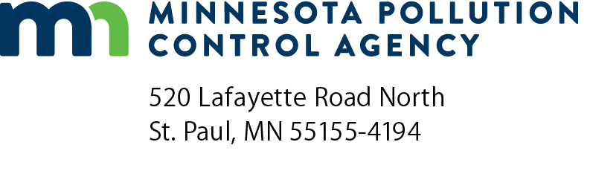 | Grant reimbursement request  Minnesota Clean Diesel Program  Doc Type: Grant application

Instructions: This form should be submitted with the required documentation for reimbursement via email to Minnesota Pollution Control Agency (MPCA) Accounts Payable at mpca.ap@state.mn.us.
Note: Required documentation must include the following for each vehicle:
- Copy of paid in full (showing zero balance) vendor invoice with the vehicle identification number (VIN) for each new vehicle.
- Completed Certificate of engine/chassis destruction form for each old vehicle.
- Photographs of the disabled chassis, engine, and VIN number of each destroyed vehicle.
Grantee information
Name: |  |  |  |  |  |  |  |  | Request number:
Total grant amount awarded: |  |  |  | $ |  |  | Request date (mm/dd/yyyy):
Total in this request: |  | $
MPCA Project Manager: |  |  |  |  |  | Grantee Project Manager:
SWIFT number (see grant agreement):
Vehicle/Equipment information
Please enter one project (vehicle/equipment) per line, as applicable.
Old vehicle/equipment description |  | Old  vehicle/equipment  VIN | New  vehicle/equipment  VIN | Original approved grant amount  (per contract) | Actual total eligible costs of new project (per RFP) | Contractor costs  (if pre-approved) | Requested grant amount
 |  |  |  | $ | $ | $ | $
 |  |  |  | $ | $ | $ | $
 |  |  |  | $ | $ | $ | $
 |  |  |  | $ | $ | $ | $
 |  |  |  | $ | $ | $ | $
 |  |  |  | $ | $ | $ | $
 |  |  |  | $ | $ | $ | $
 |  |  |  |  | Total request: |  | $ 0.00

