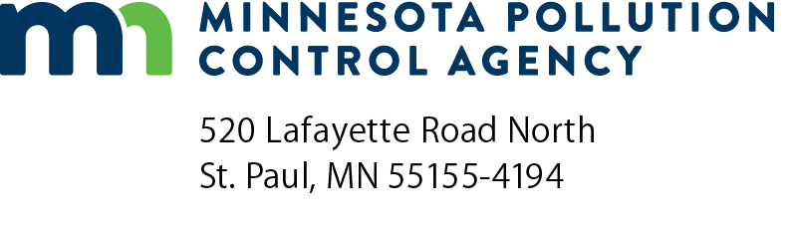 | Destructive Technology Test on  PFAS Concentrate  Grant Application  Doc Type: Grant Application
Instructions: Please read the complete Destructive Technology on Perfluoroalkyl Substances (PFAS) Concentrate Request for Proposal (RFP) before submitting this application.
Submit application: Email this completed application to grants.pca@state.mn.us with the subject line: PFAS Destructive Technologies Test Proposal. Attach additional sheets if necessary.
Applications will be accepted until all available PFAS concentrate has been dispersed or 4:00 p.m. Central Time on July 31, 2025, whichever occurs first.
Eligibility: In order to be eligible for this grant, an applicant must meet all of the following criteria:
- Demonstration of appropriate PFAS destruction technology and test project procedures;
- Demonstration of appropriate, complete chain-of-custody procedures for all stages of PFAS concentrate handling and possession from receipt through the point of disposal;
- Ability to meet the insurance requirements as listed in the sample grant agreement; and
- Ability to meet the reporting requirements as listed below.
Applicant information
Organization name:
Organization address:
City: |  |  |  |  |  |  | State: |  | Zip code: |  |  |  | County:
Contact name: |  |  |  |  |  |  |  |  | Title:
Phone: |  |  |  |  |  |  | Email address:
Project address, if different from above:
City: |  |  |  |  |  |  | State: |  | Zip code: |  |  |  | County:

Gallons PFAS concentrate requested (up to 250 gallons max):

Project information
PFAS Destruction Technology and Test Project Description
The following questions/information will demonstrate appropriate PFAS destruction technology and test project procedures
Provide a description of the PFAS destruction technology being proposed, including:
- Scientific concept behind the technology:
- Types of PFAS wastes the technology has been tested on including PFAS concentration:

Provide a description of the PFAS destruction technology test procedure
PFAS waste disposal
The following questions/information will demonstrate the appropriate, complete chain-of-custody procedures for all stages of PFAS concentrate handling and possession from receipt through the point of disposal.
Provide complete chain-of-custody procedures for all stages of PFAS concentrate handling and possession from receipt through the point of disposal.
Provide a detailed description of how the treated PFAS liquid will be transported and disposed, including:
- Documentation of transportation and disposal process including Certificate of Destruction and all associated shipping manifests/bills-of-lading to an approved disposal facility in accordance with local, state and federal regulations.
Insurance requirements
Prior to distribution of PFAS concentration, recipients will be required to submit a Certificate of Insurance as outlined in the sample grant agreement.
Will you be able to meet this requirement?
Yes No
Comments:
PFAS Destruction Test Project Deliverables
Will you be able to provide the following reports?
Yes No
Comments:
Final Report. Within eight weeks following receipt of final laboratory results, the Grantee will submit a Final Report of the destructive test to the MPCA. The Final Report shall summarize the destructive test procedure, destruction efficiencies for all PFAS parameters, other analyses necessary to demonstrate destruction effectiveness or efficiency (e.g., water quality parameters) and potential reaction byproduct formation. If the destructive test is terminated prior to the schedule completion, the Final Report shall also discuss the conclusions that led to the termination of the test and results achieved on all tasks completed.

