 | Cumulative Impacts Analysis  petition form
Instructions: Please submit completed petitions on or before the date the public notice and comment period for the draft permit ends according to Minn. R. 7007.0850, subp. 2.
As stated in the Cumulative Impacts rule, “Any person may request that the commissioner require the owner or operator of a stationary source to conduct a cumulative impacts analysis for a requested permit action that meets the applicability requirements in Minn. R. 7007.6020 by filing a petition that contains the signatures and mailing addresses of at least 100 individuals who reside or own property in the impacted environmental justice area.”
Minn. R. 7007.6060 describe the petition process and this template is not intended to replace any of those rules. This document is intended to assist users in assembling a complete petition. Further guidance for completing a petition can be found on the Cumulative Impacts website Cumulative impacts | Minnesota Pollution Control Agency.
With any questions regarding the petition process, please contact the Cumulative Impacts team (cumulativeimpacts.PCA@state.mn.us)
Submitting a petition
- Once you have completed this petition, the first step is to send the petition and all materials to the Cumulative Impacts team staff. This can be achieved in a few ways as noted below:
- Email to cumulativeimpacts.PCA@state.mn.us
If your documents are too large it is helpful to utilize a file hosting service such as Dropbox or Google drive. Once your documents are hosted on a file hosting site, email the link to cumulativeimpacts.PCA@state.mn.us and Minnesota Pollution Control Agency (MPCA) staff can then download the documents.
- Mail a hard copy of the petition and all associated documents to:
Minnesota Pollution Control Agency
520 Lafayette Road North
Saint Paul, MN 55155
2. In addition to submitting the petition to the MPCA, the petitioners (or petitioner’s representative) is responsible for notifying the owners or operators of the stationary source that a petition for a cumulative impacts analysis has been submitted regarding their stationary source. A mailed letter or including the project proposer in an email when you send the petition to the MPCA would both suffice in meeting this requirement.
3. Once MPCA staff have received the petition, they will review it for completeness. If deemed complete, MPCA staff will review the petition to determine whether to grant or deny the petition.
- If the petition is deemed incomplete, then MPCA staff will notify the petitioners’ representative of the deficiencies and provide guidance on how to resubmit a complete petition.
4. MPCA staff are available to assist regarding any questions on the petition process.
Petition introduction
This petition is being submitted to request the preparation of a Cumulative Impacts Analysis for the project:
Tips to find project name:
- Visit https://mpca.commentinput.com/comment/landingPage?lang=EN
- Select “Air Quality Permit” in the “Type” filter.
- Click “Search” button on right.
- Find project you are interested in and click on “Public Notice” button.
- Select text in top right corner of public notice; use this information in the project name field in the Petition introduction section of this form.
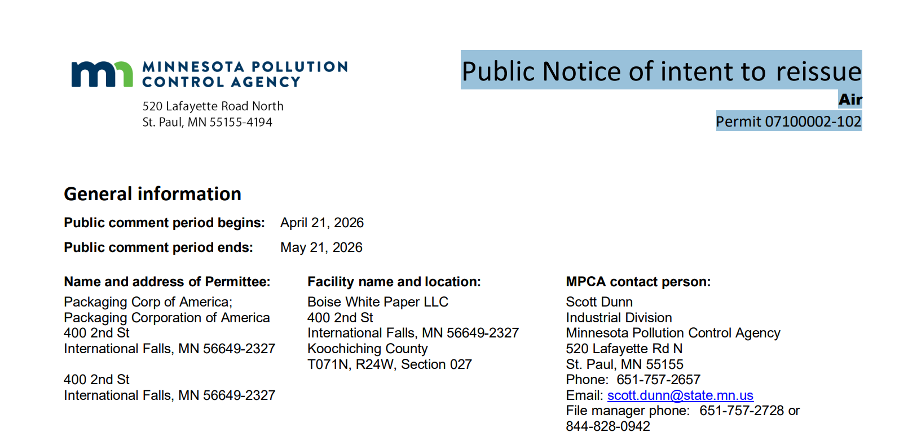
Example: “Public Notice of intent to reissue Air Permit 07100002-102”

Petition content
Items 1-6 that follow are taken from Minn. R. 7007.6060, subp. 2, item A which identifies the required contents for a petition. Please fill out items 1-6 below:
- Description of the requested permit action (Look for “This permit action […]” in public notice materials)
- Name of owner or operator of the stationary source (Please provide facility name from public notice materials)
Facility name:
Tips to find facility name:
- Follow directions listed above for finding project name in public notice
- Copy from first line under “Facility name and location” heading in public notice.
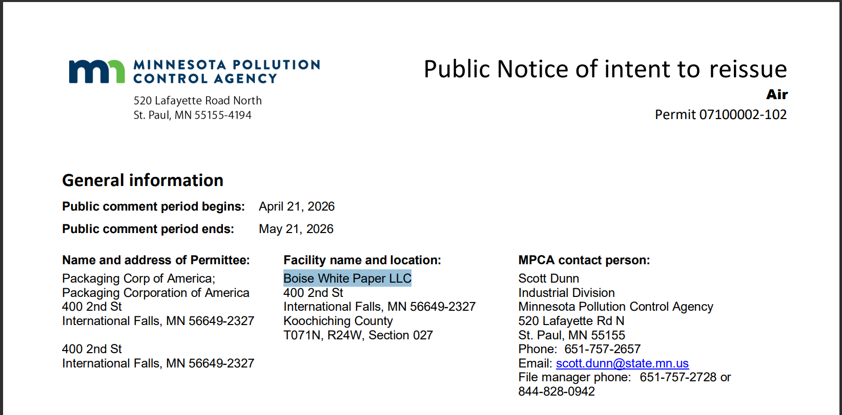
Example: “Boise White Paper LLC”

- Petitioners’ representative
Name:
Address:
City: |  |  |  |  |  | State: |  | Zip:
Phone number: |  |  |  |  | Email address:
- The name, mailing address, and signature for at least 100 individuals who reside or own property in the impacted environmental justice area (see attached pages)
- A brief description of the potential impacts of the requested permit action to the environment or health of the residents of the impacted environmental justice area.
Please explain how the potential impacts are related to the proposed project.
- If the permit action is issued, provide material evidence demonstrating the potential of substantial impact on the environment or health of the residents in the environmental justice area.
- In this section, list all pieces of material evidence to be attached to the petition.
- All material evidence must physically accompany this petition. PDF or image copies of documents or websites are acceptable. References or citations to specific pages or locations within those documents should be described in this section.
- Links to websites or citations to unattached documents are not acceptable.
- Examples include but are not limited to: scientific journal articles, letters from experts, environmental reports, maps, photographs, site plans.
- Label each piece of material evidence with a title. By titling each item of material evidence it is easier to reference how it supports the environmental concerns in Minn. R. 7007.6060, subp. 2, item A.(5).
- In addition, this section should explain how the material evidence attached demonstrates that there is potential for a substantial impact on the environment or the health of residents in the impacted environmental justice area if the permit for the requested permit action is issued. The material evidence that is included should be considered supportive evidence regarding the potential impacts provided in Minn. R. 7007.6060, subp. 2, item A.(5).

Signatures
For a petition to be complete, it must contain the names, signatures, and mailing addresses of at least 100 individuals who reside or own property in the impacted environmental justice area. Any signatures that are illegible will not be counted. Addresses must include a city or a zip code to be counted. Digital signatures are accepted. An additional template for signatures is available to print out, if needed.

Required: Legible signatures and mailing addresses of individuals (100 minimum) who reside or own property in the impacted environmental justice area. By signing this petition, you indicate that you support the information provided within the petition and believe that because of the nature or location of the proposed project, there may be potential for cumulative impacts in an environmental justice area.
 | Name (must be legible) | Address (street address, city, state, and zip code) | Signature
1
2
3
4
5
6
7
8
9
10
11
12
13
14
15
16
17
18
19
20
21
22
23
24
25
26
27
28
29
30
31
32
33
34
35
36
37
38
39
40
41
42
43
44
45
46
47
48
49
50
51
52
53
54
55
56
57
58
59
60
61
62
63
64
65
66
67
68
69
70
71
72
73
74
75
76
77
78
79
80
81
82
83
84
85
86
87
88
89
90
91
92
93
94
95
96
97
98
99
100

