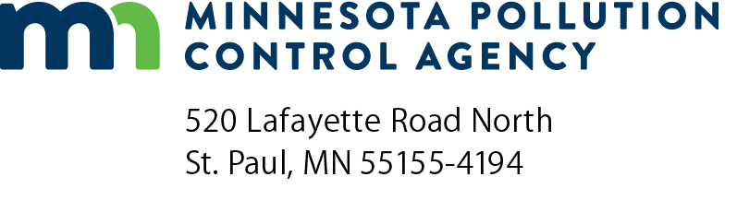 | Report Inventory  Environmental Audit Program  Doc Type: Environmental Audits

Instructions: Completion and submittal of this form satisfies the report requirements of the Environmental Audit Program.
Facility information
Facility name:
Facility address:
Contact name: |  |  | Contact phone:
Contact email:
Company information (if different from above)
Company name:
Company address:
Contact name: |  |  | Contact phone:
Contact email:

Brief description of the product(s) manufactured, the activity(ies) conducted, or the service(s) provided at this facility:

Date environmental audit completed (mm/dd/yyyy):
A Report Inventory form must be submitted within 45 days of completion of audit.

Environmental area(s) audited:
mpca audit checklists are available for a number of environmental areas. Check only the area(s) that was audited.

General |  |  |  | Industry-specific
 | Air Quality |  |  |  | Automotive Service
 | Feedlot |  |  |  | Dry Cleaning
 | Hazardous Waste |  |  |  | Fiberglass Fabrication
 | Infectious Waste |  |  |  | Motor Vehicle Salvage
 | Mining |  |  |  | Printing
 | Solid Waste |  |  |  | Wood Finishing
 | Spills |  |  |  | Hot Mix Asphalt
 | Stormwater |  |  |  | Sand and Gravel
 | Tanks (Aboveground Storage) |  |  |  | Dry Cleaning
 | Tanks (Belowground Storage) |  |  |  | Fiberglass Fabrication
 | Water Quality |  |  |  | Motor Vehicle Salvage
 | Wastewater |  |  |  | Printing
 | Other: |  |  |  | Other:

Did the scope of the audit examine the facility’s compliance with all applicable environmental requirements?
Yes No

Were violations identified?
Yes No
If yes, list the violations below, along with a description of the corrective action(s) that will be performed to correct the violations. Attach additional sheets, if necessary.
Will more than 90 days be required to correct the violations?
Yes No Not applicable.
If yes, include a performance schedule that describes when the violations will be corrected and why more than 90 days are required to correct the violations. Performance schedules are subject to MPCA approval.
If violations of local environmental ordinances or requirements were found, have the appropriate local government units received a copy of this report?
Yes No Not applicable.
If yes, include the name(s) of the local government unit(s) that received a copy of this report.
Has the facility changed its name in the past two years?
Yes No
If yes, please, write the previous name below:
Would you like MPCA staff to contact you regarding implementation of a pollution prevention program at this facility?
Yes No
Describe the steps that you will take, or have taken, to prevent the recurrence of the violations listed on the previous page. (Attach additional sheets if necessary.)
Owner or Operator signature
I certify under penalty of law that the information submitted is accurate and complete to the best of my knowledge, and that I will correct any violations identified as expeditiously as possible. Furthermore, I certify that I have either prepared a pollution prevention plan or examined pollution prevention opportunities at my facility, as discussed in the Environmental Improvement Program legislation.
Owner authorized signature: |  |  |  |  | Operator authorized signature (if different):
Signature: |  |  |  |  | Signature:
 |  | (This document has been electronically signed.) |  |  |  |  | (This document has been electronically signed.)
Title: |  |  |  |  | Title:
Date (mm/dd/yyyy): |  |  |  |  | Date (mm/dd/yyyy):
Completion and submittal of this form satisfies the report requirements of the Environmental Audit Program.

