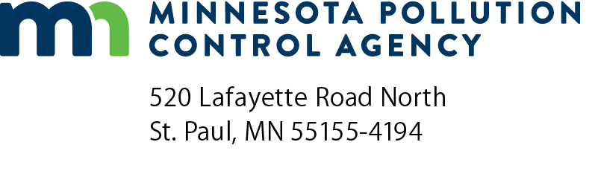 | AQDM-05  AQDM protocol review form  Air Quality Dispersion Modeling (AQDM)  (Previously AQDMPRF-01)  Doc Type: Air Dispersion Modeling
Instructions: This form is used for Minnesota Pollution Control Agency (MPCA) internal use by Air Dispersion Modelers, Air Permit Engineers, and Risk Assessors to review modeling protocols.
Note: If protocol is marked not approved, please use the AQDM-1.5 form to resubmit. AQDM-1.5 forms and updated attachments should be emailed to: AirModeling.PCA@state.mn.us. If files are too large to email, please mail a CD with the files to:
Air Quality Permit Document Coordinator
Minnesota Pollution Control Agency
520 Lafayette Road North
St. Paul, MN 55155-4194
Protocol information
Facility name: |  |  |  |  |  |  |  |  | Today’s date (mm/dd/yyyy):
AQ facility/permit ID number: |  |  |  |  |  |  | Three-letter modeling facility ID (ex., ACE, XAK, MEC, NUP, etc.):
Tempo AI ID number: |  |  |  |  |  | Date protocol was received at the MPCA (mm/dd/yyyy):
MPCA Air Dispersion Modeler: |  |  |  |  |  |  |  | MPCA Air Permit Engineer:
MPCA Air Risk Assessor:

Modeling protocol review by sections – Completed by Air Dispersion Modeler
Section name | Acceptable/ Unacceptable | Deficiencies and/or comments
Modeling purpose
Terrain
Buildings
Model selection and options
Point sources
Volume sources
Area sources
Area source coordinates
Paved roads fugitive dust
Receptors
Meteorological data
Area of impact analysis
Background values
Nearby sources
Pollutant based considerations
Attachments
Aqdm-02 Form
This section is:
Comments on status:

Modeling protocol review by sections – Completed by Air Permit Engineer
Section name | Acceptable/ Unacceptable | Deficiencies and/or comments
Modeling purpose
Modeling selection and options
Point sources
Volume sources
Area sources
Paved roads fugitive dust
Nearby sources
Pollutant based considerations
Attachment: Aqdm-02 Form
Attachment: Nearby Source Emission Calculations (If Applicable)
General Public Preclusion Plan (GPPP) |  | Additional comments (optional):
Comments on other sections:
This section is:
Comments on status:

Modeling protocol review by sections – Completed by Air Risk Assessor (If Applicable)
AERA form name | Acceptable/ Unacceptable/ Not applicable | Deficiencies and/or comments
All projects:
Deliverable checklist | AERA-01
Dispersion factor analysis | AERA-03
Emissions calculations | AERA-05
Qualitative information | AERA-02
Cumulative air emissions risk analysis | AERA-19
AERA certification | AERA-24
RASS and Q/CHI risk screening spreadsheets
If applicable:
Emergency internal combustion engine certification | AERA-04
Process flow diagram | GI-02
Facility and stack/vent diagram | GI-03
Determination checklist for proposed ethanol facilities | AERA-13
Refined HHRAP-based analysis form | AERA-26
MPCA Mercury risk estimation method (MMREM) protocol form | AERA-27
Assessing impacts of mercury release to ambient air | Hg-2003
Mercury risk assessment spreadsheet | aq9-17
Attachments:
Comments on other materials:
This section is:
Comments on status:
Overall status of modeling protocol
This modeling protocol is:
Comments on approvable-status:

