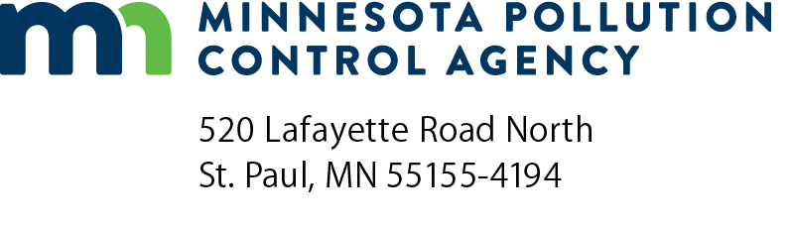 | Grant reimbursement request  Minnesota Clean Diesel Program  Doc Type: Grant application

Instructions: This form should be submitted with the required documentation for reimbursement via email to Minnesota Pollution Control Agency (MPCA) Accounts Payable at mpca.ap@state.mn.us.
Note: Required documentation must include the following for each charging station:
- Evidence of a five-year warranty from the manufacturer;
- Copy of a service contract to provide annual maintenance for five (5) years (for fast charging grants only);
- Renewable energy use commitment (if applicable);
- Photograph of charging station, signage, and stenciling on pavement; and
- Itemized receipt(s) (review your contract details).
Grantee information
Name: |  |  |  |  |  |  |  |  | Request number:
Total grant amount awarded: |  |  |  | $ |  |  | Request date (mm/dd/yyyy):
Total in this request: |  | $ |  |  |  | Total remaining grant amount: |  |  |  | $
MPCA Project Manager: |  |  |  |  |  | Grantee Project Manager:
SWIFT number (see grant agreement): |  |  |  |  |  | Purchase order number (see grant agreement):
Invoicing period (actual working period)
Equipment information
Please enter one project (equipment) per line, as applicable.
Station  location | Other  station description | Station  serial number | Original approved grant amount  (per contract) | Total eligible costs of project (per RFP) | Requested reimbursement amount
 |  |  | $ | $ | $
 |  |  | $ | $ | $
 |  |  | $ | $ | $
 |  |  | $ | $ | $
 |  |  | $ | $ | $
 |  |  | $ | $ | $
 |  |  | $ | $ | $
Total Requested Reimbursement amount: |  |  |  |  | $

