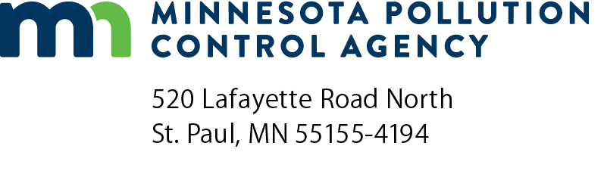 | DRF-2  Deviation Reporting Form  Air Quality Permit Program  Doc Type: Excess Emission Report

Instructions: Complete and sign form, then create a PDF copy and email to: AQRoutineReport.PCA@state.mn.us.
For more information visit the Air permit compliance forms webpage.

General Information about Deviation and Compliance Reporting
If your permit requires you to submit deviation reports or an annual compliance certification, you should use the Deviation Reporting Forms (DRFs) and Annual Compliance Certification Report (CR-04), unless you get Minnesota Pollution Control Agency (MPCA) approval to use another format or your facility’s permit specifies otherwise. There are two separate DRF forms: DRF-1 and DRF-2.
DRF-1 | is used to report direct excess stack emissions recorded by Continuous Emission Monitoring Systems (CEMS) and Continuous Opacity Monitoring Systems (COMS).
DRF-2 | is used to report all deviations to permit conditions not recorded by CEMS including deviations of permitted operating conditions, surrogate parameters, failure to meet a requirement, or potential excess emissions identified through monitoring or recordkeeping. Reporting downtime is also required whether due to missed manual readings or monitor malfunction.
 | Some examples: flow rate, temperature, throughput, control equipment operating parameters, fuel-use records
CR-04 | is used to report facility compliance status at the end of each year if required by your permit.

General Facility Information
AQ permit number: |  |  |  | Agency Interest ID number:
Facility name: |  |  |  | County:
 | Time period covered by report: January 1 - June 30 July 1 - December 31 |  |  |  | (year)

Description of Deviations
Provide the following information regarding each individual deviation from permit conditions identified by either your periodic or continuous monitoring system. Be sure to report any deviations which occurred during monitor downtime or monitor bypasses. Use the same numbering system as used in the facility permit.
Date of deviation | Emission unit ID no. | Monitor  ID no. | Cite permit condition which was deviated from | Detailed description of deviation, why it occurred, and corrective action taken

Description of Monitor Downtime
Provide the following information regarding each period when a periodic or continuous monitoring system for any permitted operating condition or surrogate parameter did not record required data. Use the same numbering system as used in facility permit.
Date and time of missed record | Monitor  ID no. | Emission unit ID no. | Pollutant or parameter monitored | Cause of the monitor downtime and  corrective action taken

Summary of Deviations and Monitor Downtime
Fill out a separate row of the table for each periodic monitoring system.
Monitor ID no.  (Use same number from facility permit.) | Total number of readings taken  (during period covered by report) | Total number of readings indicating deviations | Percent of readings indicating deviations  (To calculate, divide total number of readings taken that indicate deviations by the total number of readings. Multiply that number by 100.) | Total no. of readings missed  (Indicate the number of times that data was not recorded as required by your permit.) | Total percentage of readings missed  (Divide number of readings missed during reporting period by number or readings required during same period. Then multiply by 100.)
Deviations Discovered Through Recordkeeping
List each deviation that was discovered through recordkeeping (e.g., your fuel use records indicate that you exceeded your fuel use limits). Provide at least the date(s) of each deviation; magnitude of deviation; associated emission unit, the cause of each deviation, and the corrective action taken.
1.
2.
3.
Certification
I certify under penalty of law that this document and all attachments were prepared under my direction or supervision in accordance with a system designed to assure that qualified personnel properly gather and evaluate the information submitted. Based on my inquiry of the person or persons who manage the system, or those persons directly responsible for gathering the information, the information submitted is, to the best of my knowledge and belief, true, accurate, and complete.
Responsible Official
Print name: |  | Title:
Signature: |  | Date:
Note: The individual signing must meet the definition of “responsible official” in Minn. R. 7007.0100, subp. 21.
Due Dates
Air Emission Permit – Option D, where control equipment is used to reduce actual reported emissions | Deviation Report – if a deviation occurred | January 30 and July 30
Air Emission Permit – State or Federal Total Facility or General | Deviation Report – whether or not a deviation occurred | January 30 and July 30
 | Compliance Certification | January 31

