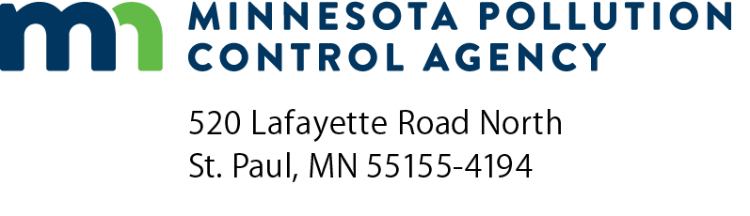 | CS-01  Compliance Schedule Progress Report  Air Quality Permit Program  Doc Type: Notifications
Instructions: Email a signed and scanned PDF copy of this form to: AQRoutineReport.PCA@state.mn.us.
Submit this form only if you are subject to a compliance schedule (in Table C of your permit). Compliance schedule progress reports must be submitted to the MPCA at least semiannually, or as otherwise specified in Table C. All progress reports must be certified by a responsible official, defined in Minn. Rules 7007.0100, subp. 21
If you prefer, you may submit this form in another format, such as a computer-generated spreadsheet. However, make sure to provide all required information in the same order in which it appears on this form.
1a) AQ Facility ID number: |  |  | 1b) Agency Interest ID number:
2) Facility name:

3) Fill in the following table, using Table C of your permit as a reference:

3a) Corrective Action  (Include all corrective actions from Table C.) | 3b) Date corrective action scheduled to be achieved | 3c) Date corrective action actually achieved | 3d) If the deadline in column 3b has not yet passed, or it the deadline in column 3b has passed and the corrective action has yet to be achieved, describe the current status of all activities related to the required corrective action. | 3e) If the deadline in column 3b was not met (or will not be met), indicate:  i) why the deadline was not (or will not be) met; and  ii) any preventative measures you have taken (or will take) as a result.

Certification
Permittee responsible official: |  |  |  |  | Co-Permittee responsible official (if applicable)
Signature: |  |  |  |  | Signature:
 |  | (This document has been electronically signed.) |  |  |  |  | (This document has been electronically signed.)
Title: |  |  |  |  | Title:
Date (mm/dd/yyyy): |  |  |  |  | Date (mm/dd/yyyy):

