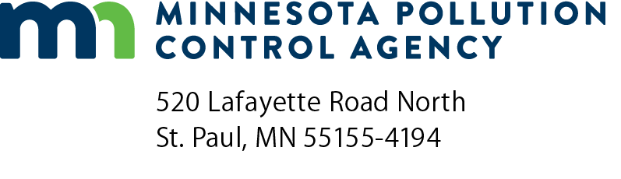 | TF-08  Exceedance Report for  Halogenated Solvent Cleaning Machines  Halogenated Solvent Cleaning Equipment  Air Quality Permit Program  Doc Type: Notification
Instructions: Annual Reports are due, postmarked or received, by the 30th day following the reporting period.
When to Report | What to Report
Semiannually | If there were no exceedances.
Quarterly | If there were exceedances.
1st Quarterly Exceedance | Must be submitted in the quarter following the occurrence of the exceedance.
Reduced to Semiannually | If there have been no exceedances for one year, you continue to comply with all monitoring and recordkeeping requirements, and the MPCA has agreed to your written request for a reduced reporting frequency.

Submit completed report to both:
Minnesota Pollution Control Agency  AQ Compliance Tracking Coordinator:  AQRoutineReport.PCA@state.mn.us | George Czerniak  AE-17J  U.S. EPA Region 5  77 West Jackson Boulevard  Chicago, IL 60604-3507

For assistance, call:
For businesses with 100 or fewer employees:  Small Business Environmental Assistance Program  Metro: 651-282-6143; Statewide: 800-657-3938 | For other facilities with more than 100 employees:  MPCA Customer Assistance Center  Metro: 651-296-6300; Statewide: 800-657-3864
Halogenated Solvent Cleaning NESHAP*
*NESHAP = National Emissions Standards for Hazardous Air Pollutants
Facility name:
AI ID: |  |  |  | County Facility is located in:

Facility name:
Mailing address:
City: |  |  | State: |  | Zip code:
Facility Contact Person
Name: |  | Title:
Email: |  | Phone: |  | Fax:
Responsible Official
Name: |  |  | Title:
Signature: |  |  | Date (mm/dd/yyyy):

Fill out a separate form for each solvent cleaning machine.
1. | Facility’s machine identification no.:
 | Model no.: |  |  |  |  |  |  |  |  |  |  |  |  |  |  | Serial no.:
2. | Type of cleaning machine: |  |  |  |  |  | Batch Vapor In-Line
3. | Solvent/air interface area is: |  |  |  |  |  |  |  |  |  |  |  | square feet |  |  | or |  |  | square meters
4. | If your cleaning machine has no solvent/air interface area, then give the cleaning capacity of your machine:
 |  |  |  | cubic feet |  | or |  |  |  |  |  | cubic inches
5. | This submittal is for:
 |  |  | Semiannual |  | 1st half |  |  |  | 2nd half |  |  |  |  | Year:
 |  |  | Quarterly |  | 1st quarter |  |  |  |  | 2nd quarter |  |  |  |  |  |  | 3rd quarter |  |  |  | 4th quarter | Year:
Certification
I certify that:
No exceedance of a parameter occurred, or a piece of equipment has been inoperative, out of control, repaired or adjusted for the specified reporting period
An exceedance did occur for the specified reporting period as follows:
Date(s) of occurrence:
Reason for exceedance(s):
Action(s) taken (include replacement parts, repairs made, additional monitoring to demonstrate parameters have been returned to accepted levels):

