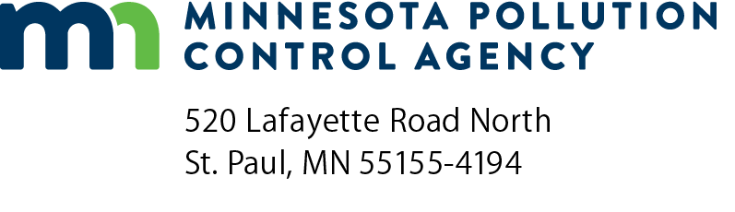 | TF-07  Annual Report for  Halogenated Solvent Cleaning Machines  Halogenated Solvent Cleaning Equipment  Air Quality Permit Program  Doc Type: Notification
Instructions: Annual Reports are due, postmarked or received, by February 1 each year for the preceding year. Submit completed report to both:
Minnesota Pollution Control Agency  AQ Compliance Tracking Coordinator:  AQRoutineReport.PCA@state.mn.us | George Czerniak  AE-17J  U.S. EPA Region 5  77 West Jackson Boulevard  Chicago, IL 60604-3507

For assistance, call:
For businesses with 100 or fewer employees:  Small Business Environmental Assistance Program  Metro: 651-282-6143; Statewide: 800-657-3938 | For other facilities with more than 100 employees:  MPCA Customer Assistance Center  Metro: 651-296-6300; Statewide: 800-657-3864
Halogenated Solvent Cleaning NESHAP*
*NESHAP = National Emissions Standards for Hazardous Air Pollutants
Facility name:
AI ID: |  |  |  | County Facility is located in:

Facility name:
Mailing address:
City: |  |  | State: |  | Zip code:
Facility Contact Person
Name: |  | Title:
Email: |  | Phone: |  | Fax:
Responsible Official
Name: |  |  | Title:
Signature: |  |  | Date (mm/dd/yyyy):

Annual Report form complying with 40 CFR 63.463
Fill out a separate form for each solvent cleaning machine that uses the idling emission standard or the control combination to comply with the rule.
1. | Facility’s machine identification no.:
 | Model no.:
2. | Type of cleaning machine: |  |  |  |  | Batch Vapor In-Line
3. | Solvent/air interface area is: |  |  |  |  |  |  |  |  | square feet |  |  |  | or |  | square meters
4. | If your cleaning machine has no solvent/air interface area, then give the cleaning capacity of your machine:
 |  |  |  | cubic feet | or |  |  |  | cubic inches
5. | Compliance approach: (tables are found in 63.463)
 |  |  | Batch Vapor Control Combination Option No.: |  |  |  |  |  |  |  |  |  |  |  |  |  | from Table:
 |  |  | In-Line Control Combination Option No.: |  |  |  |  |  |  |  |  |  |  |  |  |  | from Table:
 |  |  | Idling Emission Standard
6. | Training Certification statement:
 |  |  | I certify that all operators of solvent cleaning machines have received training on the proper operation of solvent cleaning machines and their control devices sufficient to pass the required test in 63.463 (d) (10).
 | Date of last training for operators (mm/dd/yyyy):

 | Halogenated solvent | Annual consumption* in pounds per year
 | Methylene Chloride (CAS# 75-09-2) |  | Actual | Estimated
 | Perchloroethylene (CAS# 127-18-4) |  | Actual | Estimated
 | Trichloroethylene (CAS# 79-01-6) |  | Actual | Estimated
 | 1,1,1-Trichloroethane (Methyl Chloroform) (CAS# 71-55-6) |  | Actual | Estimated
 | Carbon Tetrachloride (CAS# 56-23-5) |  | Actual | Estimated
 | Chloroform (CAS# 67-66-3) |  | Actual | Estimated
*consumption means the amount of halogenated hazardous air pollutant solvent added to the solvent cleaning machine.

Annual Report form complying with 40 CFR 63.464
Fill out a separate form for each solvent cleaning machine that uses the alternative standard (the overall emission limit) to comply with the rule.
1. | Facility’s machine identification no.:
 | Model no.:
 | Serial no.
2. | Type of cleaning machine: |  | Batch Vapor In-Line Batch cold Immersion Remote-Reservoir
3. | Solvent/air interface area is: |  |  |  |  | square feet | or |  |  | square meters
 | My cleaning machine has no solvent/air interface.
4. | Cleaning capacity of machine: |  |  |  |  | cubic feet | or |  |  | cubic meters
5. | Compliance approach:
 | Alternative Standard/Overall Emission Limit
6. | Average monthly solvent consumption in pounds per month:

 | pounds | (Previous 12th month) | From: |  | To:

 | pounds | (1st month) | From: |  | To:

 | pounds | (2nd month) | From: |  | To:

 | pounds | (Previous 12th month) | From: |  | To:

 | pounds | (Previous 12th month) | From: |  | To:

 | pounds | (Previous 12th month) | From: |  | To:

 | pounds | (Previous 12th month) | From: |  | To:

 | pounds | (Previous 12th month) | From: |  | To:

 | pounds | (Previous 12th month) | From: |  | To:

 | pounds | (Previous 12th month) | From: |  | To:

 | pounds | (Previous 12th month) | From: |  | To:

 | pounds | (Previous 12th month) | From: |  | To:

 | pounds | (Previous 12th month) | From: |  | To:

