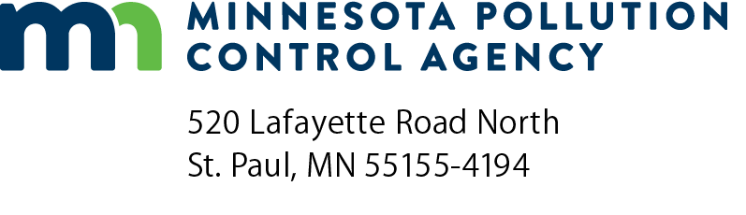 | TF-03  Compliance Report for Batch Cold Cleaning  Halogenated Solvent Cleaning Equipment  Air Quality Permit Program  Doc Type: Notification
Instructions: Submit completed report to both:
Minnesota Pollution Control Agency  AQ Compliance Tracking Coordinator:  AQRoutineReport.PCA@state.mn.us | George Czerniak  AE-17J  U.S. EPA Region 5  77 West Jackson Boulevard  Chicago, IL 60604-3507

For assistance, call:
For businesses with 100 or fewer employees:  Small Business Environmental Assistance Program  Metro: 651-282-6143; Statewide: 800-657-3938 | For other facilities with more than 100 employees:  MPCA Customer Assistance Center  Metro: 651-296-6300; Statewide: 800-657-3864
Halogenated Solvent Cleaning NESHAP*
NESHAP = National Emissions Standards for Hazardous Air Pollutants
AI ID: |  | (Leave this line blank if you do not have a number.)
Permit Number: |  | (Leave this line blank if you do not have a number.)
Person preparing form
Date (mm/dd/yyyy):
Last name: |  |  |  | First name: |  | Middle Initial:

Facility name:
Mailing address:
City: |  |  |  | State: |  | Zip code:
Equipment location address
Street address:
City: |  |  | State: |  | Zip code:
Cleaning machine summary
Identification number | Description
- For existing machines, due 5/1/1998 (existing cleaning machines are those installed on or before 11/29/93.)
- For new machines, due 150 days after startup or 5/1/1995, whichever is later (new cleaning machines are those installed after 11/29/1998.)
Information required per cleaning machine (Make copies for additional machines, as necessary.)
Cleaner Identification Number:
Cleaning machine type: | Immersion |  | Remote-Reservoir

This batch cold cleaner complies with the rule.
Signature: |  | Date (mm/dd/yyyy):

Method of Compliance (check one):
Cover and Water Layer
Cover and a 0.75 Freeboard Ratio or Greater with Work Practices
Cover with Work Practices

