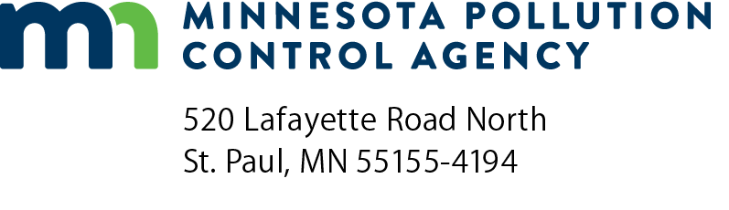 | TF-01  Initial Statement of Compliance Report -  Alternative Standard/Overall Emission Limit  Halogenated Solvent Cleaning Equipment  Air Quality Permit Program  Doc Type: Notification
Instructions: This report must be postmarked or received by the applicable due date, located at the bottom of this page. Submit completed report to both:
Minnesota Pollution Control Agency  AQ Compliance Tracking Coordinator:  AQRoutineReport.PCA@state.mn.us | George Czerniak  AE-17J  U.S. EPA Region 5  77 West Jackson Boulevard  Chicago, IL 60604-3507

AI ID: |  | Date (mm/dd/yyyy):
Facility name:
Facility address
Street address: |  |  |  |  | County:
City: |  |  | State: |  | Zip code:
Mailing address
Street address:
City: |  |  | State: |  | Zip code:

Facility contact person: |  |  | Phone number:
Title:
Responsible official
Name:
Title:
Signature: |  |  |  | Date (mm/dd/yyyy):
Cleaning machine (fill out separate form for each solvent tank)
1. | Tank Identification No.:
 | Date of tank installation (mm/dd/yyyy):
 | Tank is: | Existing | (This report is due by May 1, 1998)
 |  | New | (This report is due 150 days after start-up or May 1, 1995, whichever is later)

2. | Type of machine: | Batch vapor
 |  | In-Line

 | Solvent/Air Interface area: |  | square meters
 |  | or
 |  |  | square feet
 |  | My cleaning machine has no solvent/air interface.

3. | Tank description (Model No., Serial No., etc.):

4. | Cleaning capacity of your machine: |  | cubic meters
 |  | or
 |  |  | cubic feet
General Instructions for Overall Emission Limit Also Known As Alternative Standard
- This option allows you the flexibility to establish your own emission-reduction strategy provided you comply with the overall emission limit.
- Applicable overall emission limits are based on your cleaning machine type and size.
- If you comply with the limit specified for your machine, you do not have to follow any additional equipment monitoring or work practice requirements.
- In addition, operators of machines complying with this option are not subject to the solvent cleaning procedures test. This is a test that the MPCA can give during an inspection. This test ensures that each operator has adequate knowledge of solvent cleaning operating procedures. Each operator of a solvent cleaning machine must complete and pass applicable sections of a solvent cleaning procedures test, when requested by the MPCA.
- This option is generally easiest to comply with when a machine is either well-controlled or infrequently used.
To determine the 3-month average monthly emission limit for your machine, multiply the solvent/air interface area (size) of the machine by the applicable limit (shown in table below):
Machine Type | 3-Month Average Monthly  Emission Limit (kg/m2 x month)ª | 3-Month Average Monthly  Emission Limit (lbs/ft2 x month)^{b}
Batch Vapor | 150 | 30.7
Existing In-Line | 153 | 31.4
New In-Line | 99 | 20
ª m² = The total surface area of all cleaning tanks for a particular machine (i.e., solvent/air interface area).
^{b} ft² = The total surface area of all cleaning tanks for a particular machine (i.e., solvent/air interface area).

If your machine does not have a solvent/air interface area:
- Your emission limit is based on your machine’s cleaning capacity.
- An emissions limit based on your machine’s cleaning capacity is only an option if your machine does not have a solvent/air interface area.
- An emission limit based on your machine’s cleaning capacity is not a compliance option for a machine with a solvent/air interface area.
Determine your machine’s cleaning capacity in one of the following ways:
Check the literature that was provided with your machine at the time of purchase to see if it includes a measurement of the cleaning capacity for your cleaning machine;
or
Ask the manufacturer of your machine for the cleaning capacity;
or
Determine the cleaning capacity of your machine from the following information:
- The internal width (IW) (specify meters or feet) of the cleaner tank;
- The internal width (IW) (specify meters or feet) of the cleaner tank;
- The internal length (IL) (specify meters or feet) of the cleaner tank; and
- The depth (D) (specify meters or feet) of the cleaner tank.
- The cleaning capacity is obtained by multiplying the above numbers together (i.e., Capacity = IW x IL x D)

Records of the cleaning capacity determination for each of your machines without a solvent/air interface are to be maintained on-site in paper or electronic form for the lifetime of the machine.
5. | If your machine does not have a solvent/air interface area, explain the calculation methods and the results used to determine the cleaning capacity of your machine: (attach a separate sheet of paper, if necessary)

6. | The first 3 month average emissions for this machine is: |  | kg/month
 |  | or
 | (Calculation sheets should be attached.) |  | lb/month

7. | For all facilities with halogenated solvent cleaning machines, please fill in the following information:

 | Halogenated Solvent | Annual Consumption* for 1997 (in lbs) | Annual Consumption  for 1996 (in lbs)
 | Methylene Chloride (CAS# 75-09-2) |  |  | Actual | Estimated
 | Perchloroethylene (CAS# 127-18-4) |  |  | Actual | Estimated
 | Trichloroethylene (CAS# 79-01-6) |  |  | Actual | Estimated
 | 1,1,1-Trichloroethane (Methyl Chloroform) (CAS# 71-55-6) |  |  | Actual | Estimated
 | Carbon Tetrachloride (CAS# 56-23-5) |  |  | Actual | Estimated
 | Chloroform (CAS# 67-66-3) |  |  | Actual | Estimated
 | *Consumption means the amount of halogenated hazardous air pollutant solvent added to the solvent cleaning machine.
- If you use actual annual consumptions for 1996, fill in the amount and check the “actual” box.
- If you do not have actual annual consumption records for 1996, give us your best estimate for the amounts and check the “estimated” box.

